***mzStudio Tutorial (version 1.2.4)***

Updated 2017-08-08

1. ***mzStudio: Installation***

**Installation - overview:**

1- Install **Python 2.7 64-bit** from <https://www.python.org/ftp/python/2.7.13/python-2.7.13.amd64.msi>

2- Install **.NET** from <http://www.microsoft.com/en-us/download/details.aspx?id=17718>

3- Install **wxPython3.0-win64-3.0.2.0-py27.exe** (WX version 3.0.2.0 for 64-bit Python 2.7); download from <https://sourceforge.net/projects/wxpython/files/wxPython/3.0.2.0/wxPython3.0-win64-3.0.2.0-py27.exe/download>

4- Install **multiplierz** via pip: from command line, run "c:\python27\scripts\pip install multiplierz --upgrade".

5- Download **mzStudio** (zip) from <https://github.com/BlaisProteomics/mzStudio>, extract zipped files and run! The first time you run the program, it will ask if you’d like to configure the interfaces to vendor raw data files. Click Yes. Then type ‘Y’ in the console when prompted to install MSFileReader. After this, mzStudio will launch!

Questions? Problems? Email [Scott_Ficarro@dfci.harvard.edu](mailto:Scott_Ficarro@dfci.harvard.edu) or [WilliamM_Alexander@dfci.harvard.edu](mailto:WilliamM_Alexander@dfci.harvard.edu)

**Detailed Installation Guide:**

**1- Install Python 2.7 64-bit** from <https://www.python.org/ftp/python/2.7.13/python-2.7.13.amd64.msi>

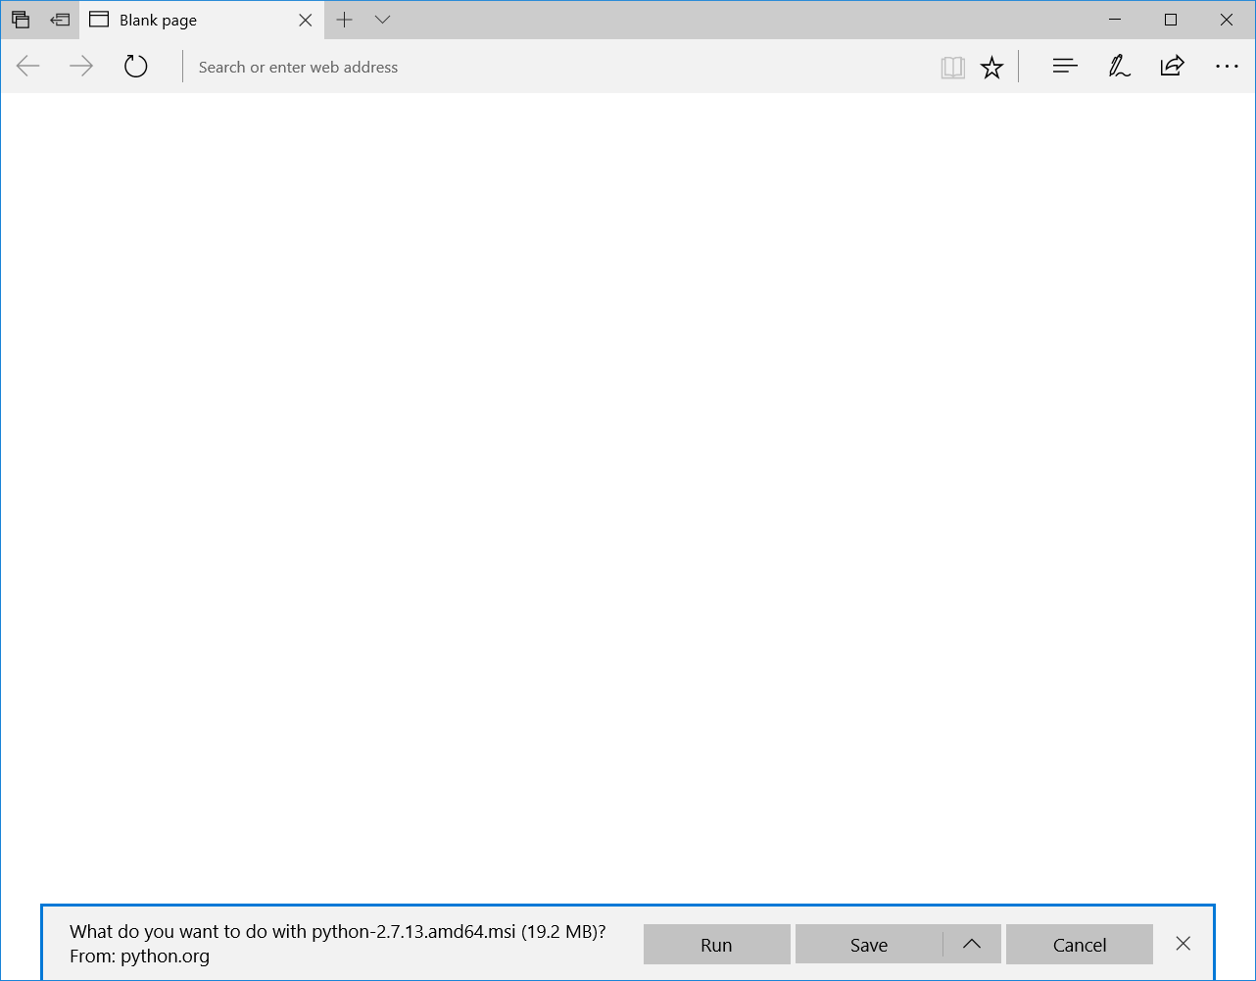

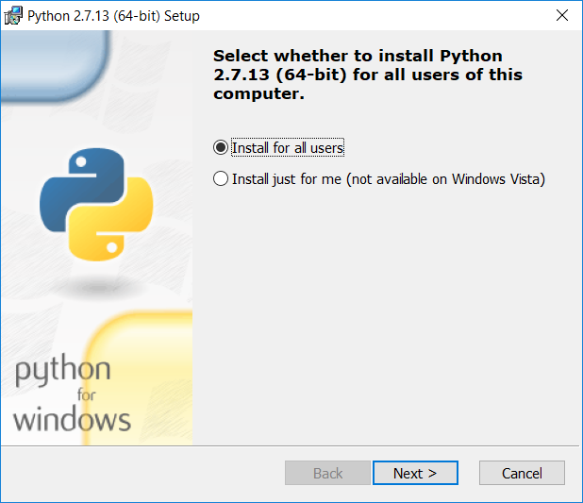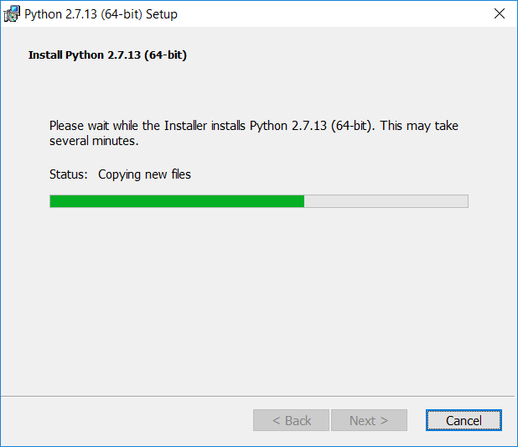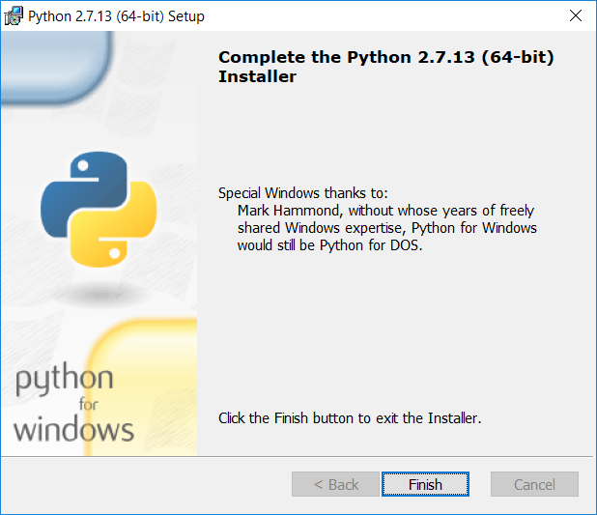

**2- Install .NET** from <http://www.microsoft.com/en-us/download/details.aspx?id=17718>

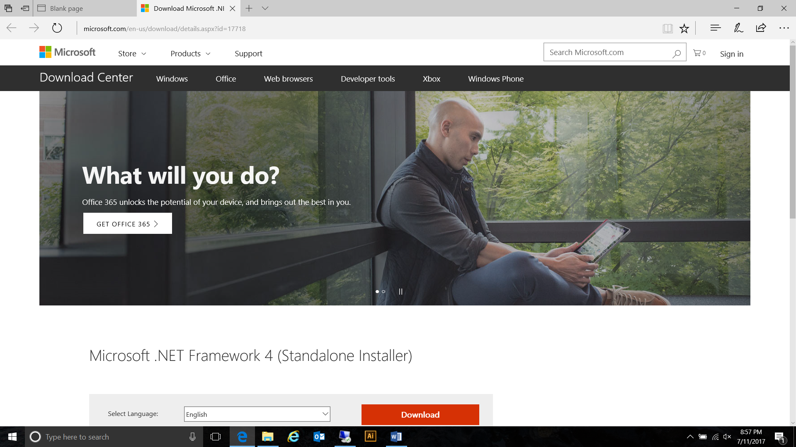

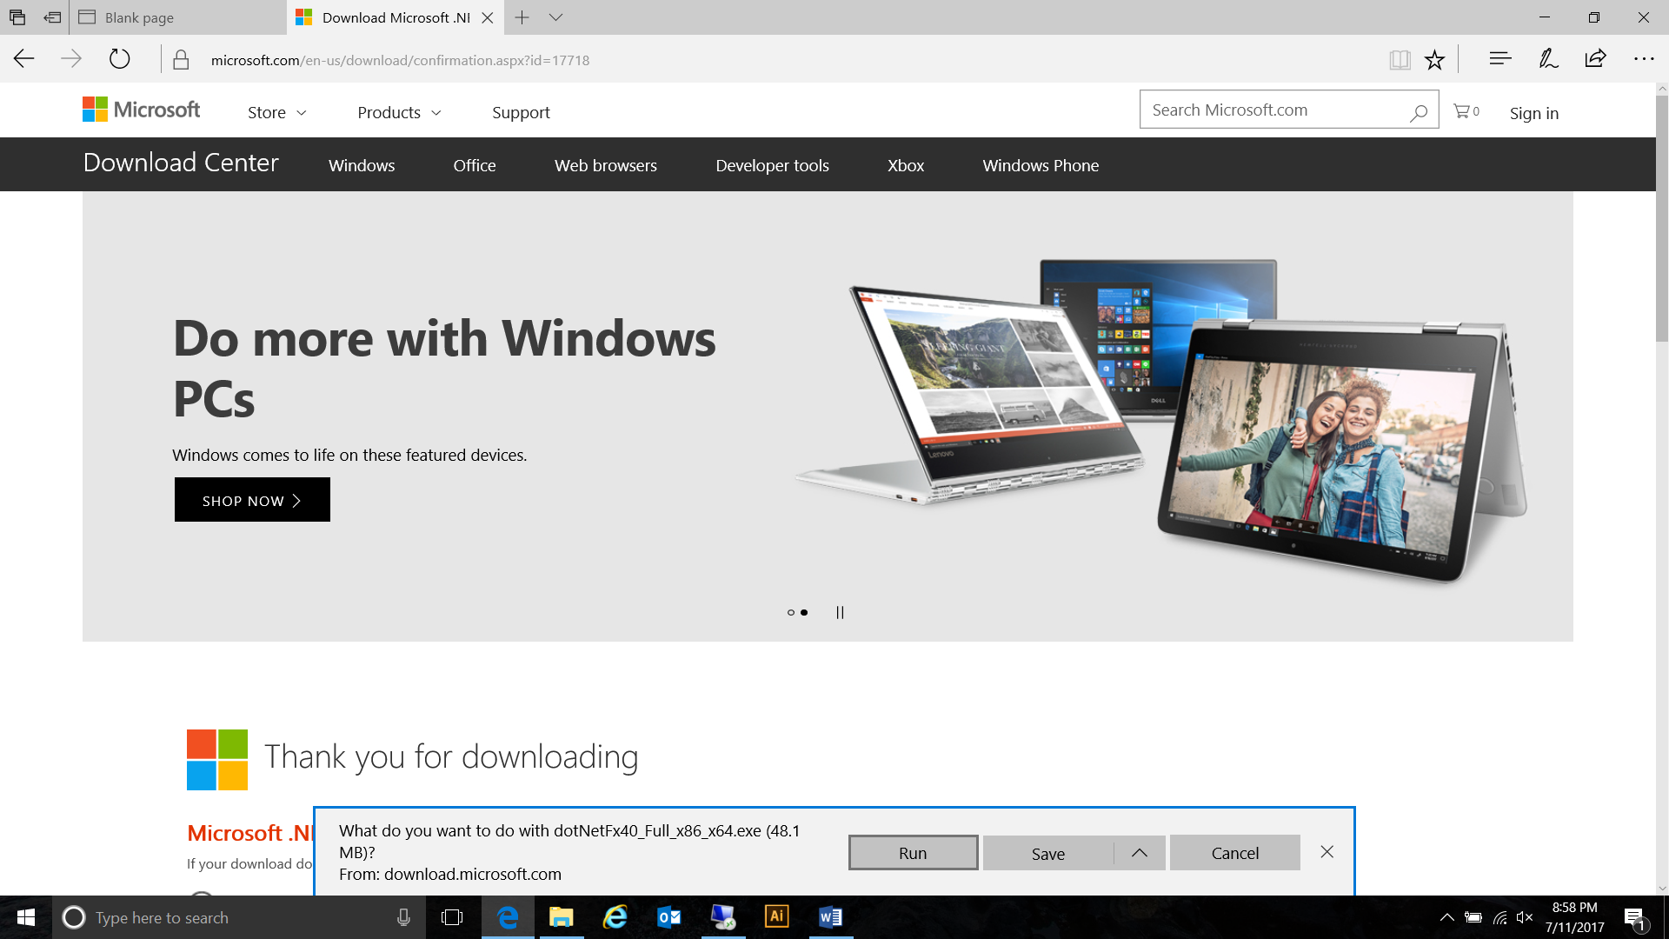

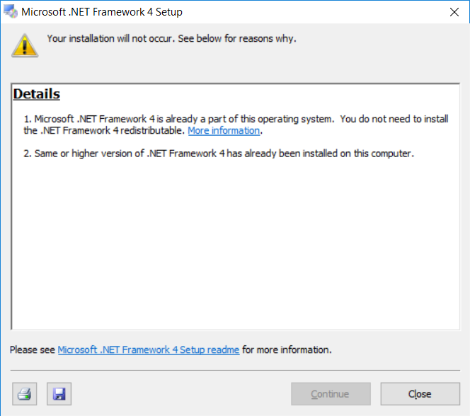

On this computer, it was already installed! If not, follow instructions to install.

**3- Install wxPython 3** download wxPython 3.0.2.0, 64-bit, for Python 2.7 from sourceforge and install:

<https://sourceforge.net/projects/wxpython/files/wxPython/3.0.2.0/wxPython3.0-win64-3.0.2.0-py27.exe/download>

After the download is complete, run the installer!

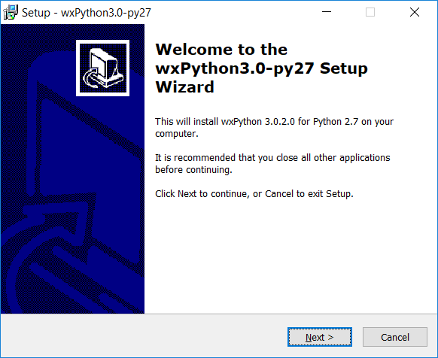 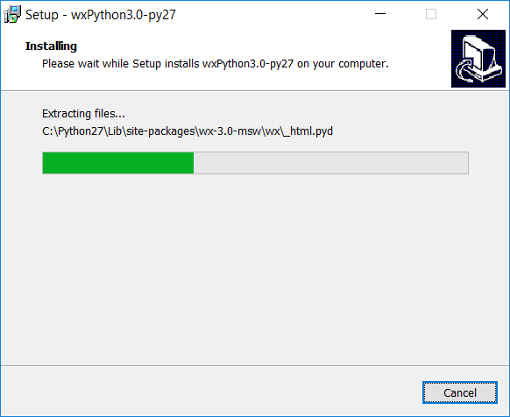

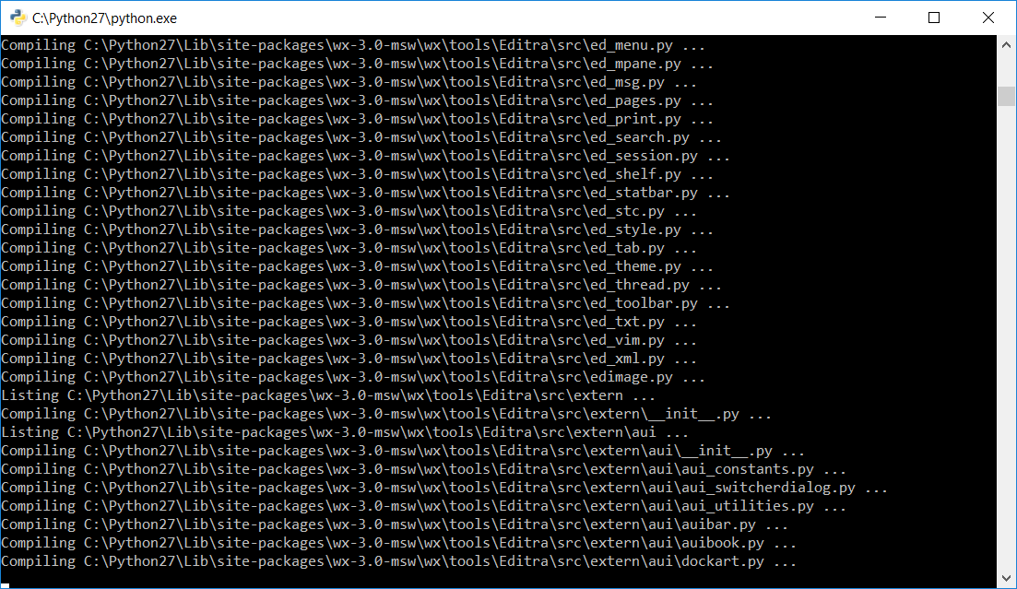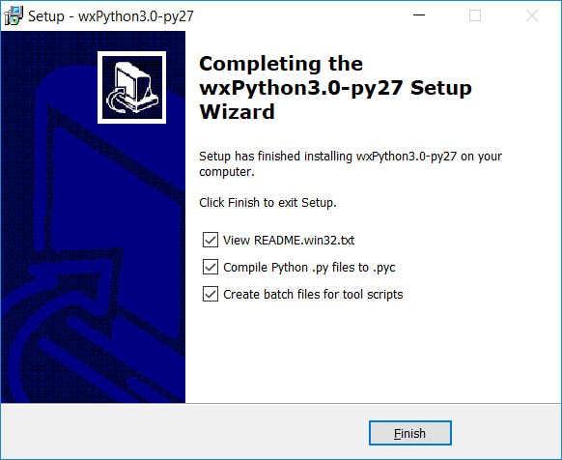

Click finish to compile files. Installer compiles modules… Done!

**4- Install multiplierz via pip**: from command line, run "c:\python27\scripts\pip install multiplierz --upgrade".

The --upgrade flag will update modules if newer versions are available in case older versions are present. Note, your python27 installation may be in a different directory (this was chosen during install process), so adjust the path accordingly!

Pip is a handy installer for python modules; open a command prompt and type the command above. Multiplierz and all dependent modules will be downloaded, extracted and installed!

On windows 10, to open a command prompt, type “cmd” in the search bar.

On windows 7, press the start button, and type “cmd” in the search bar.

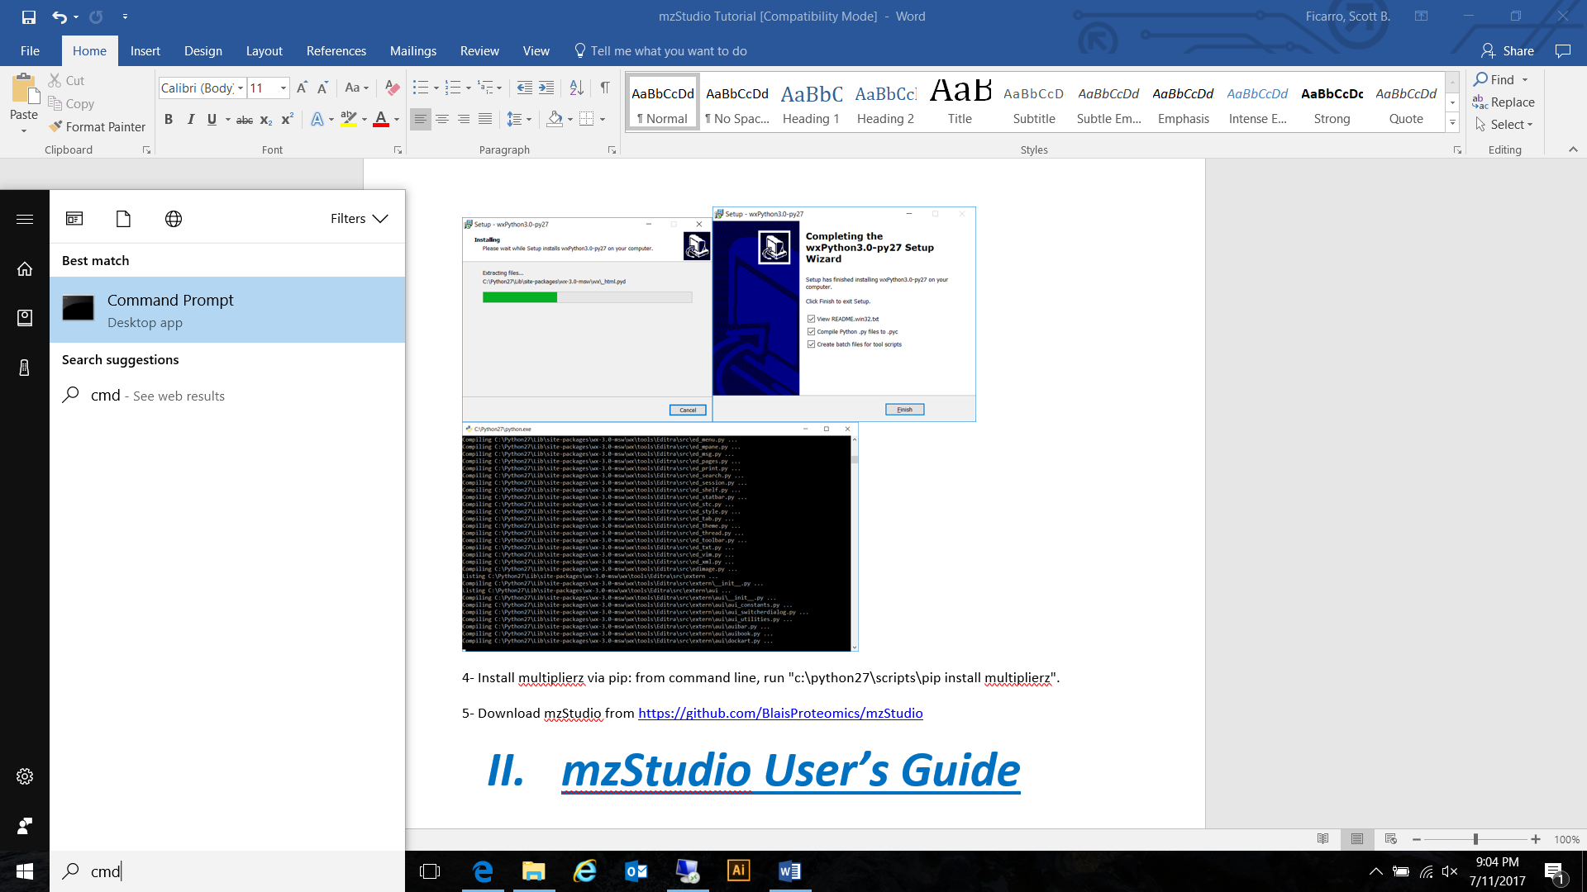



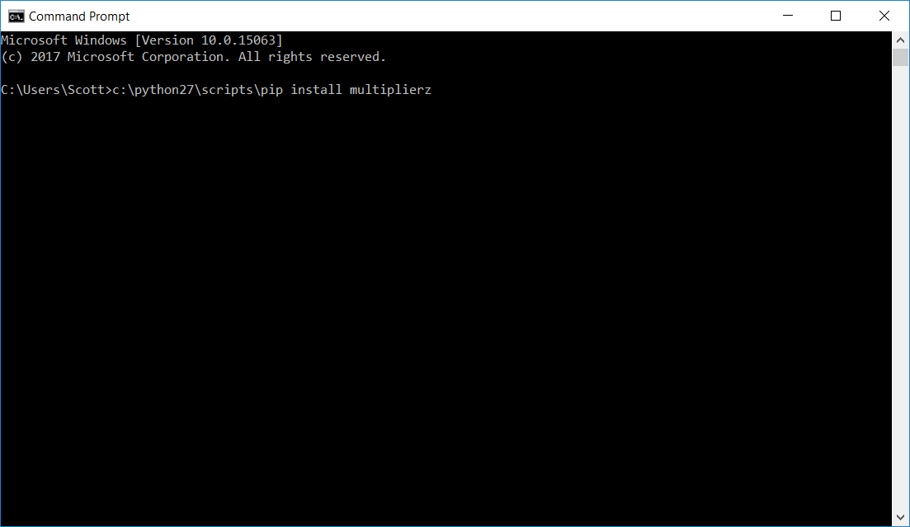

Note, this was a first installed on a new system, so --ugrade flag was not used; it is generally better to include this in case older module versions are present on the system.

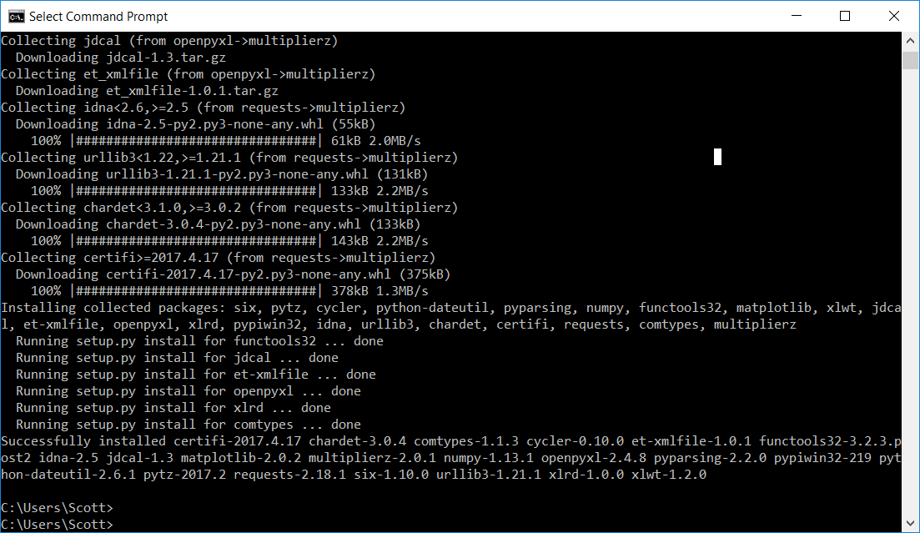

**5- Download mzStudio** from <https://github.com/BlaisProteomics/mzStudio>, extract and run!

Click Clone or download, and Download ZIP.

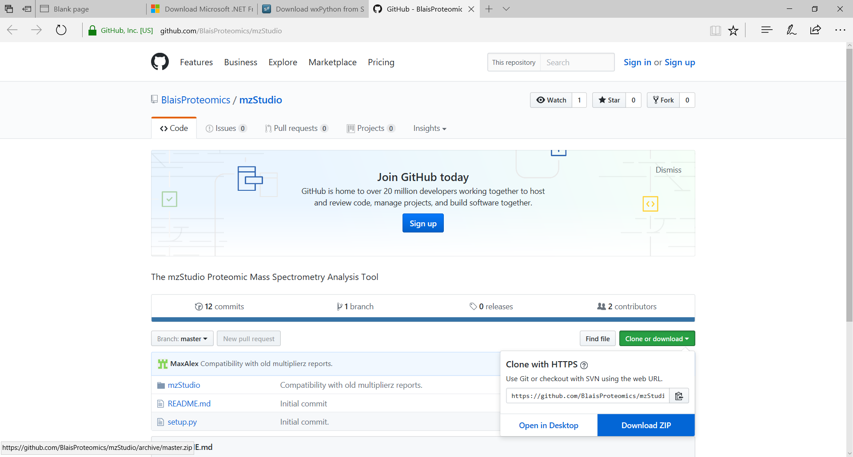 

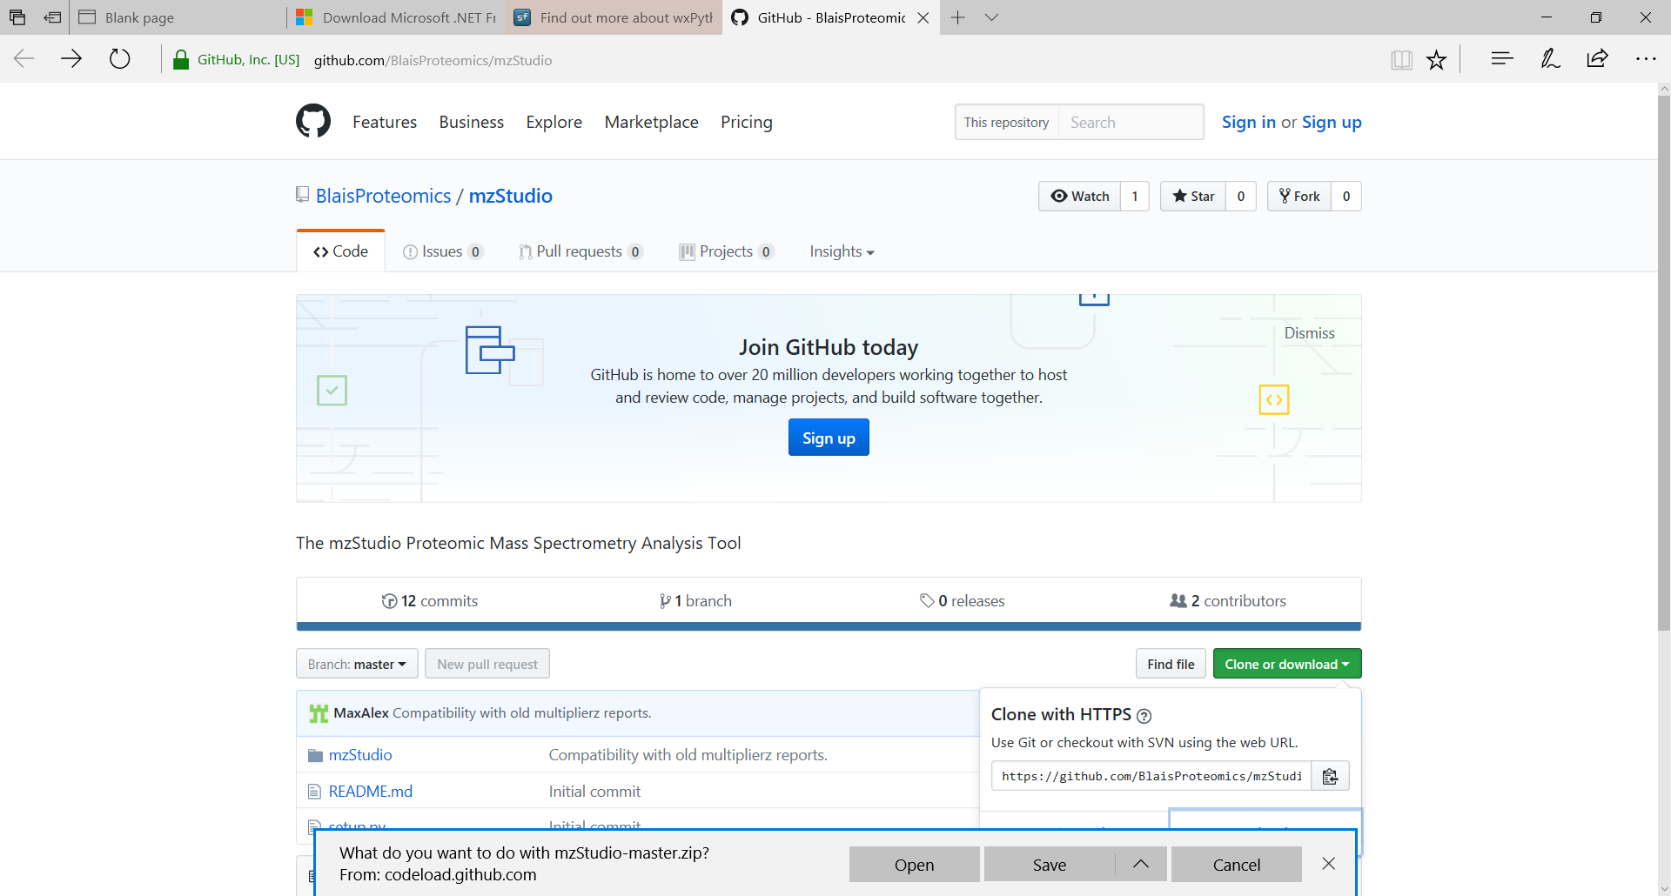

Extract the zip files.

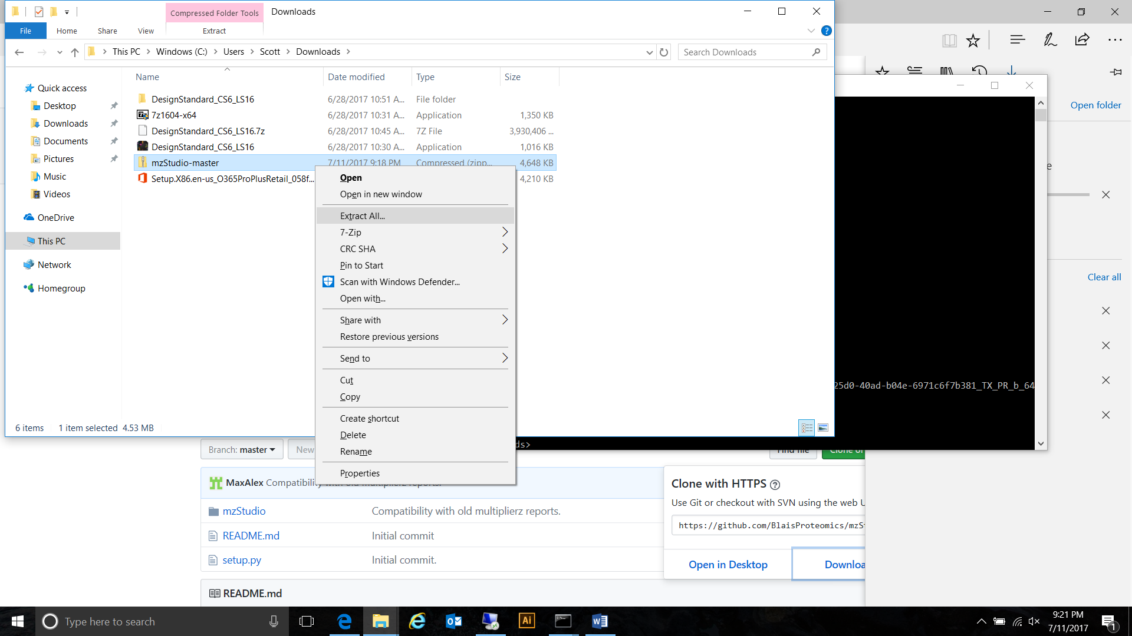 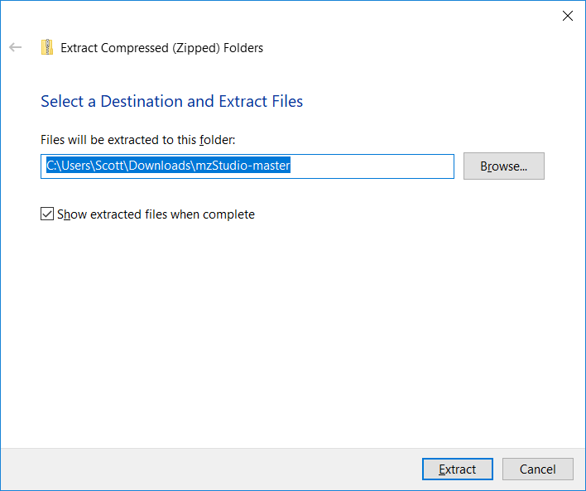

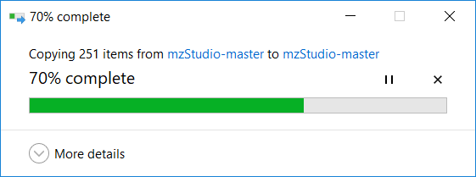

Open a command prompt (as described above), and run mzStudio!

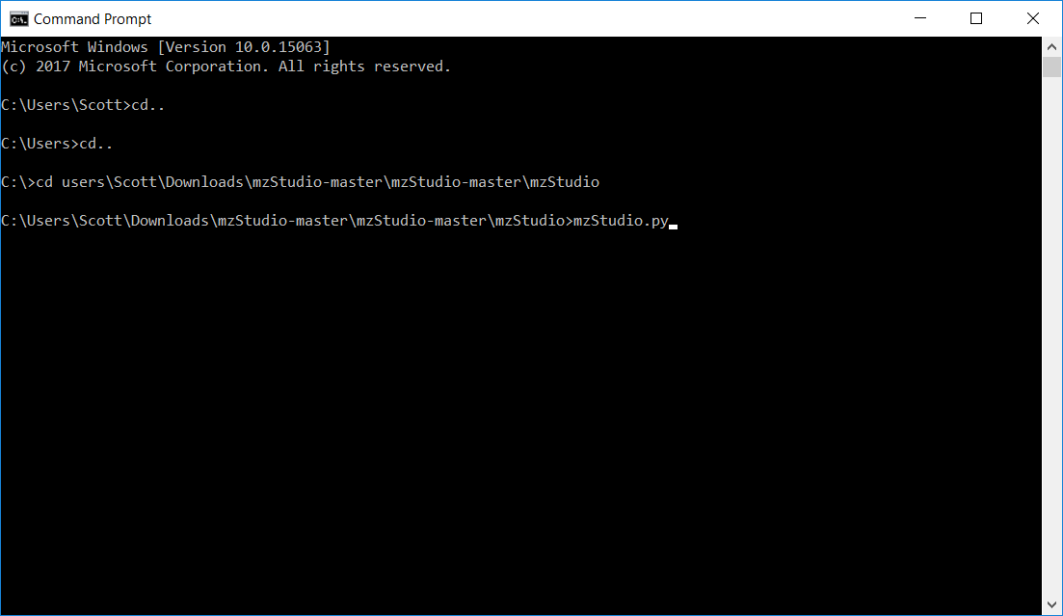

When you launch the program, it checks to see if the interfaces to the mass spectrometry data files have been configured. If not, (for example, the first time you launch the program), you will see the message:

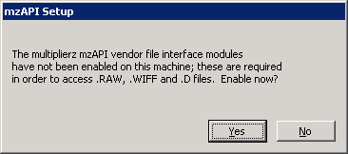

Click Yes to setup the interfaces.

After enabling .wiff (ABSciex), .t2d (ABSciex), and .d (Agilent) file access, it will ask if you want to install the MSFilereader (.raw access). Type Y, and enter.

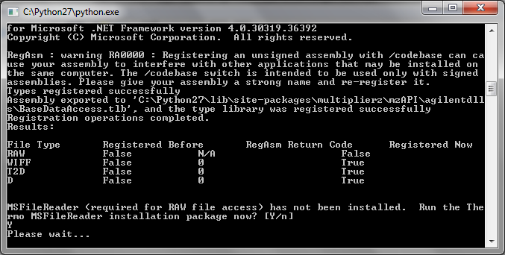

Follow directions to install MSFilereader.

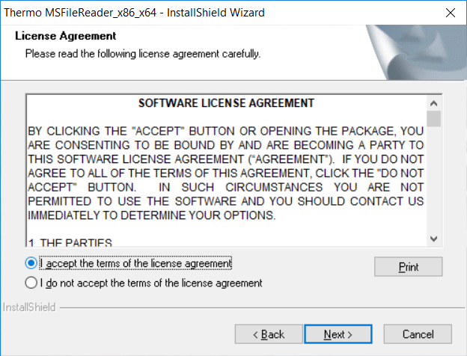

Once vendor library access is configured, mzStudio will open!

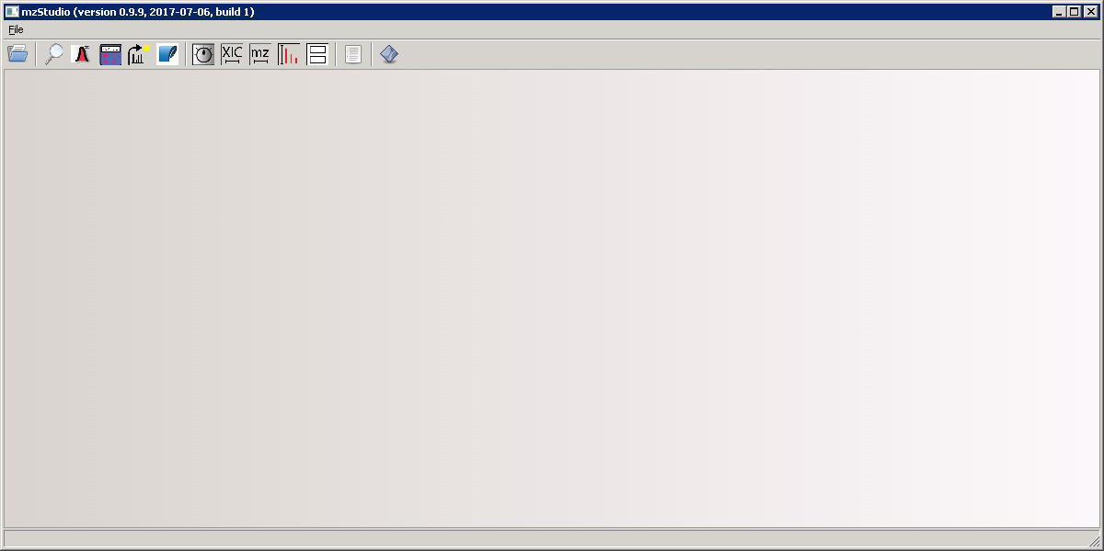

To make it easier to launch the program, I find it handy to make a .bat file and place it on the desktop.

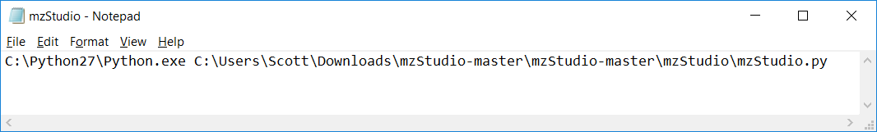

Just open up notepad, type the path to your python executable (i.e. C:\Python27\Python.exe), and then the path to mzStudio.py (adjust your path accordingly depending on where you extracted your files). Click File/Save as… Browse to the desktop, then select “All files” in the “Save as type“ box and enter mzStudio.bat as filename.

Double clicking the .bat file will directly open mzStudio!

1. ***mzStudio User’s Guide***

**Some tutorial files to use**

An exemplary data file and search results can be downloaded from sourceforge:

<https://sourceforge.net/projects/mzstudio-tutorial-package/files/latest/download?source=navbar>

**Opening a file**

mzStudio currently supports direct access to raw mass spectrometry data files from Thermo, AB-Sciex, and Agilent, as well as multiplierz generated .mgf files.

To open a Thermo raw file, an AB-Sciex wiff or t2d file, or an mgf file, select the “Open MS data file (New Tab)” menu item. This opens a file dialog. Browse to the desired file, and click the Open button.

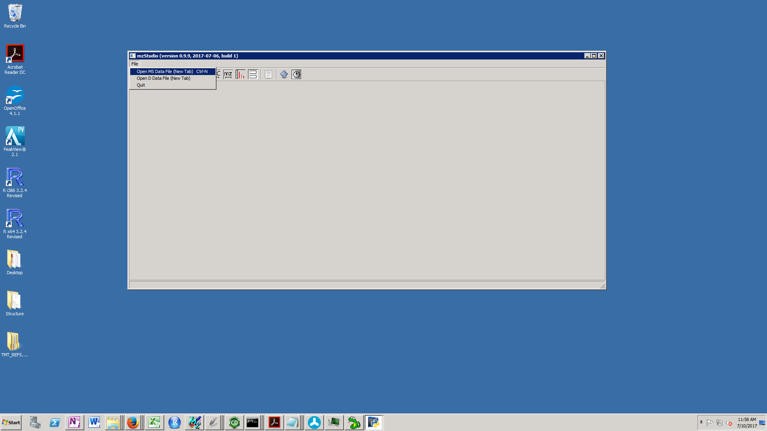

To open an Agilent file, select the “Open D data file (New Tab)” menu item. This opens a directory dialog. Browse inside the data file folder – here you should see an “AcqData” folder (don’t open this though) - hit the “Select Folder” button.

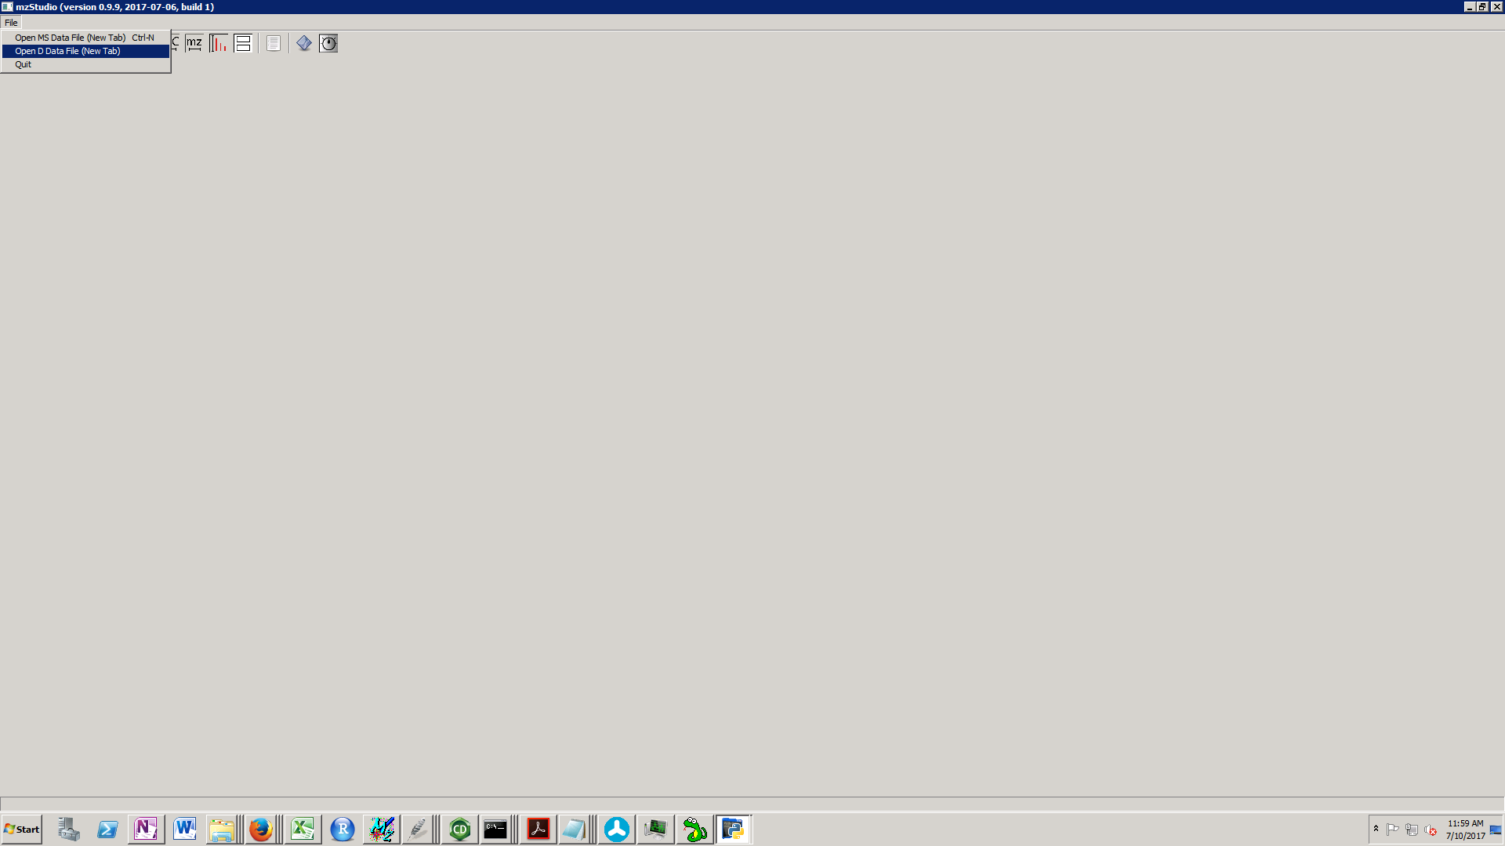

After opening a file, a TIC is displayed, along with the first spectrum. This is the tutorial file 2011-07-29-eno-100fmol-1.raw.

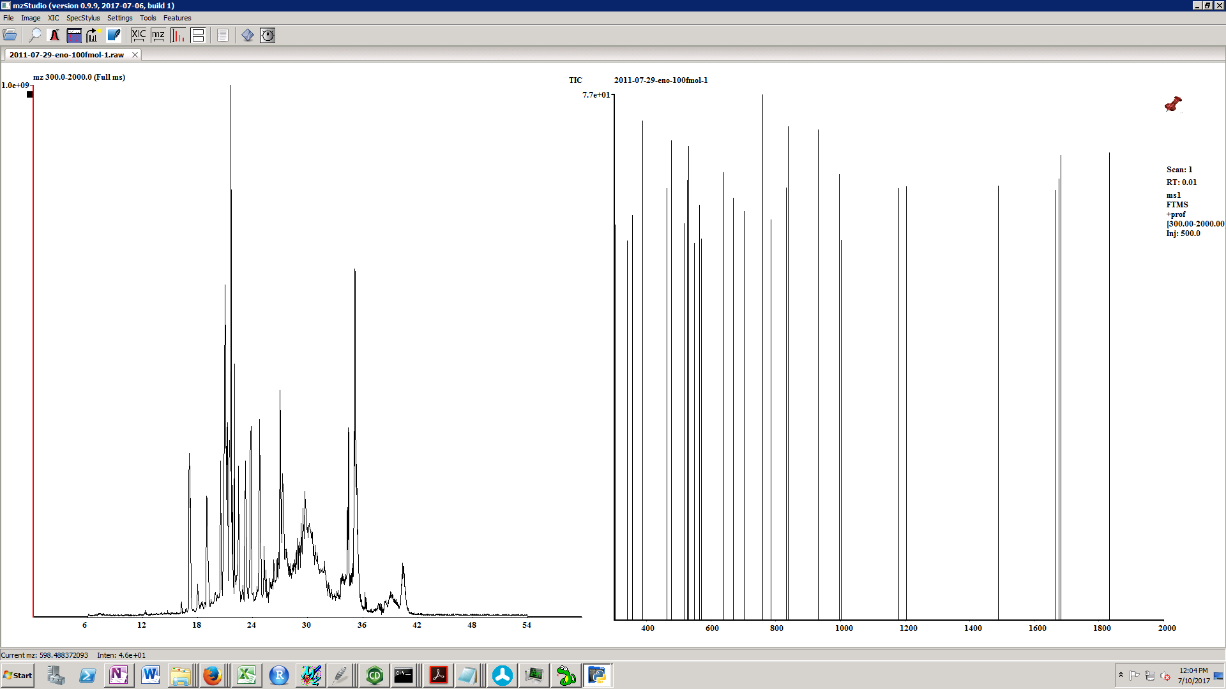

***Basic Navigation***

**Helpful tip: When typing key commands, make sure the spectrum window has focus. If focus is lost, just left click the mass spectrum – commands will now be sent to the spectrum window!**

**+/-** go to next or previous scan.

**<** and **>** go to the next or previous MS1 scan for files with MS1 data.

Left click in XIC displays the spectrum for the selected retention time.

Left click & drag in XIC panel zooms in the selected time range.

Right click in XIC panel zooms out to the entire time range.

Right click & drag in XIC performs peak integration according to method specified in settings (see section below on peak areas).

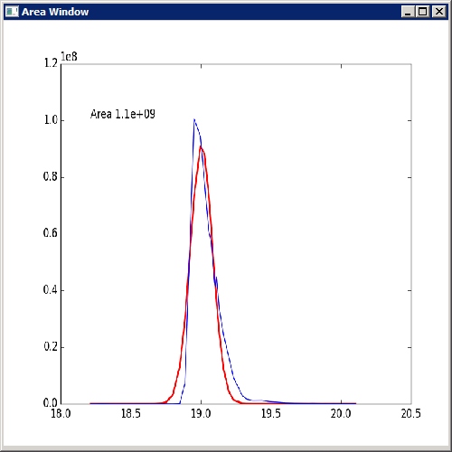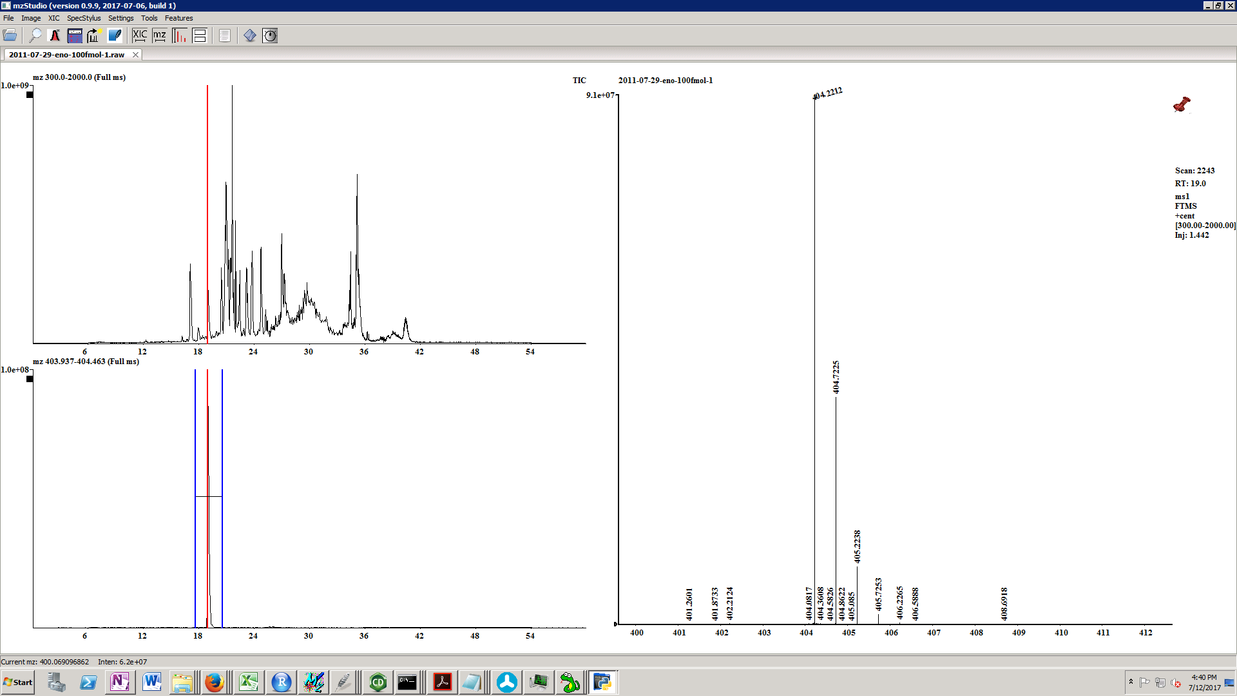

Left click & drag in spectrum zooms in on the selected mass range.

Right click on the spectrum displays the full mass range (zoom out).

1,2,3 displays the mass spectrum on the indicated number of axes.

R selects XIC/Spectrum display mode (side-by-side).

S selects Spectrum display mode (no XICs).

L toggles locking the mass range. When locked, the displayed range stays the same moving from scan-to-scan.

W toggles the “filter lock”. This applies to targeted MS2 or MSn experiments. When the filter is locked, < and > move to the next scan or previous scan with the same filter.

**Toolbar items**

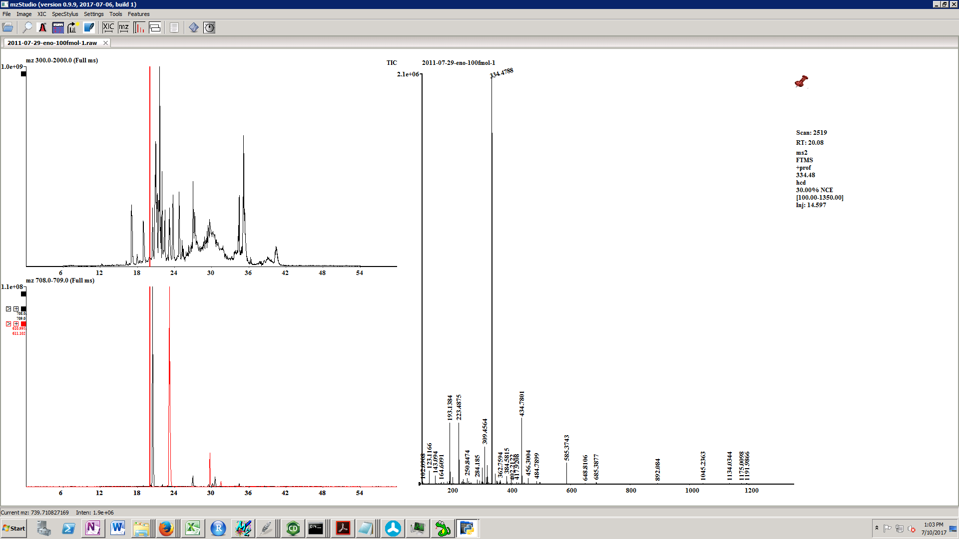

In order, the toolbar icons are as follows:

1.  ***Open a data file*** (same as File Menu/Open MS Data File (New Tab))
2.  ***Search for MS2 spectra***.

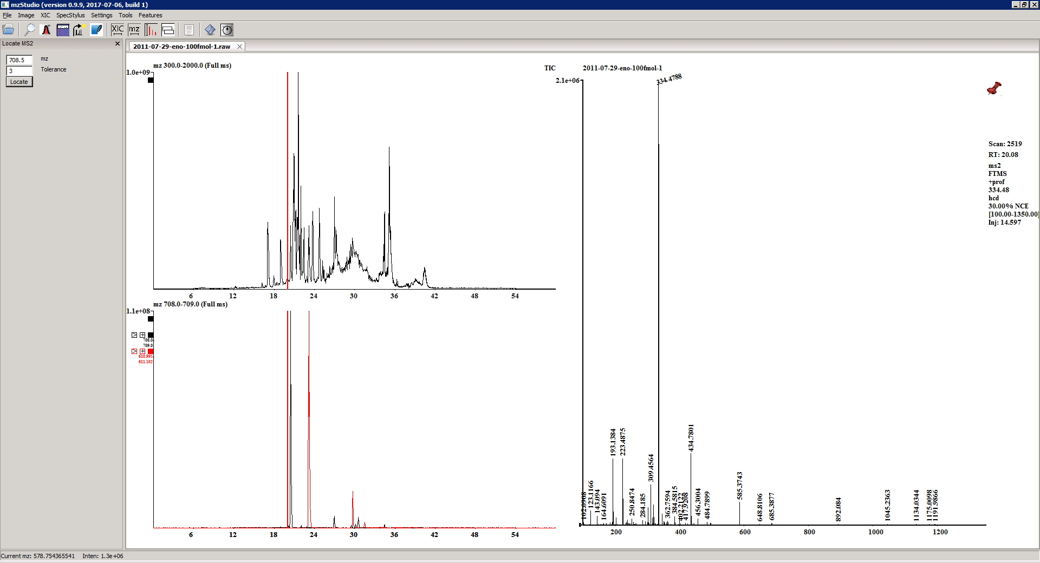

Enter mz and tolerance. Click locate. A grid appears:

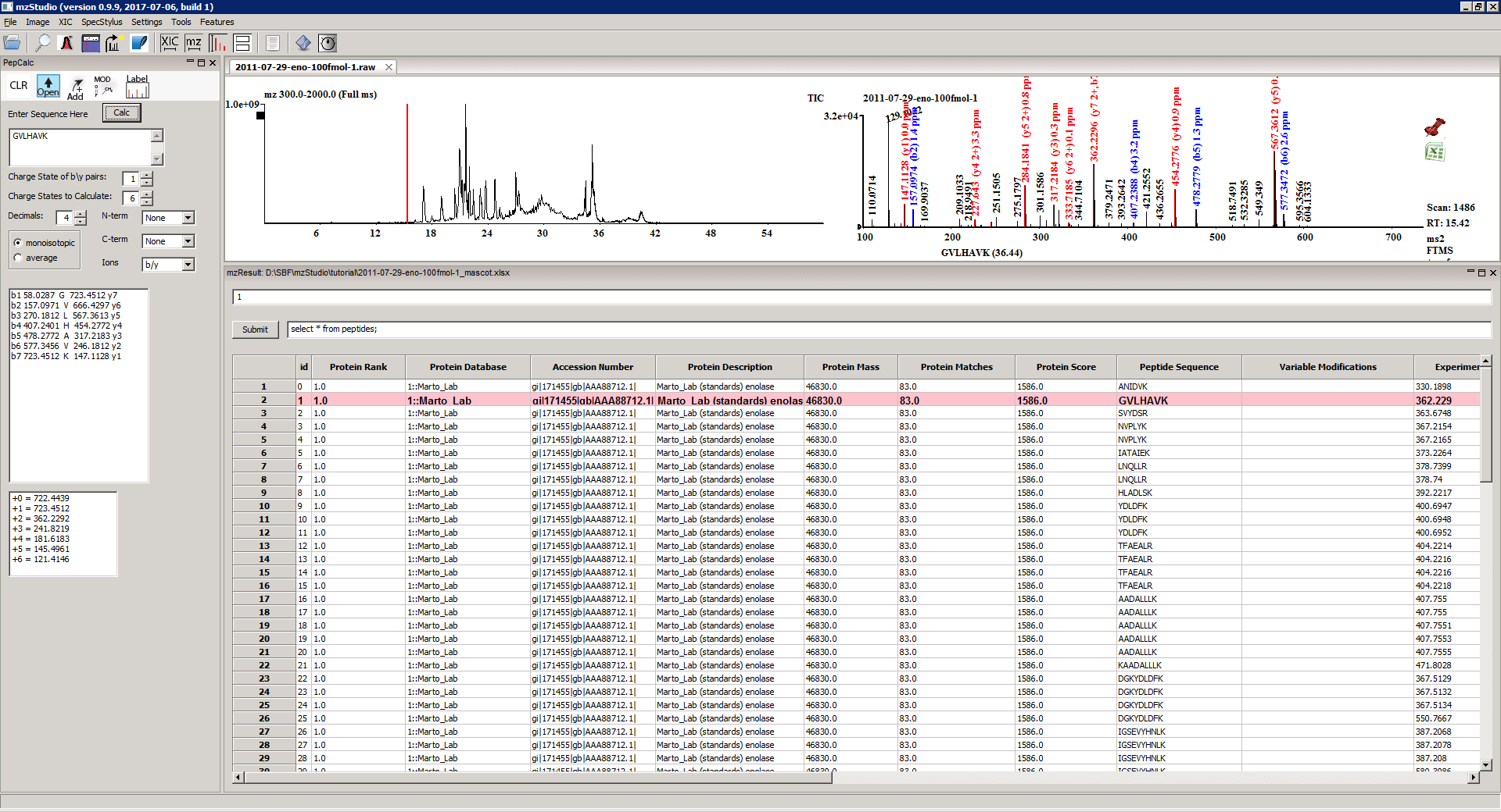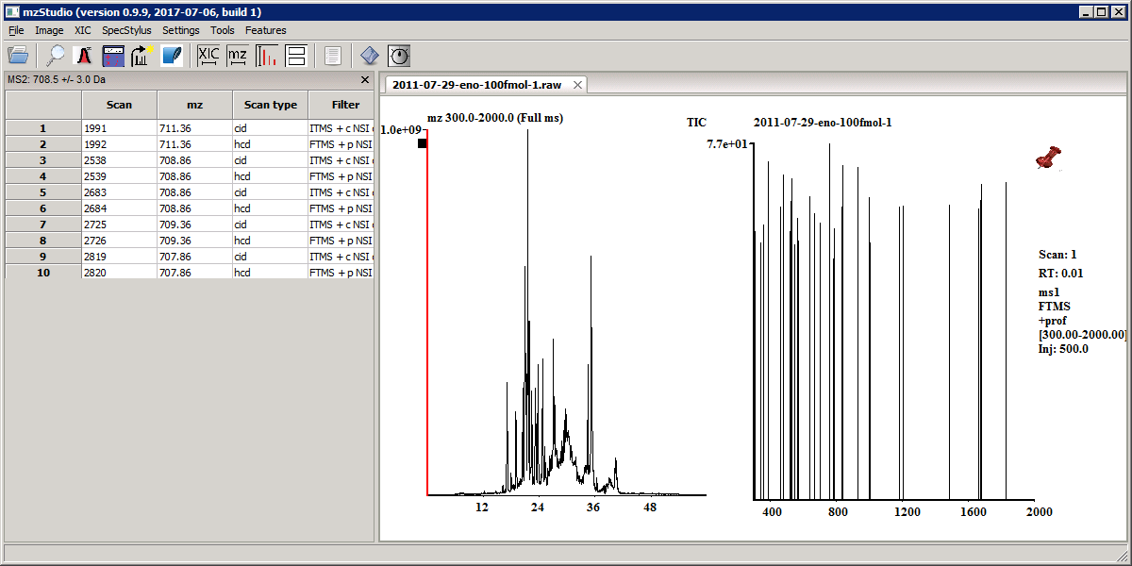

Click on the row label to jump to the listed scan.

1.  ***Perform an XIC*** (same as menu item XIC/XIC)

See section below on *extracted ion chromatograms*.

1. ***Open mzPepCalc***.



mzPepCalc is a very useful tool for calculating fragment ion masses.

Enter the peptide sequence in the sequence box.



Set the charge state of the fragment ions you would like to calculate with the spinner box.

Set the highest charge state precursor you would like to display with the labeled spinner box (‘6’ will calculate from ‘+0’ or unprotonated to ‘+6’ charge state).



Then select # of decimals to display, N-term mods, C-term mods, ion type (i.e. b/y or c/z) and whether average or monoisotopic masses should be used.

Hitting the calc button will calculate precursor and product ion masses, and display the results in the list boxes.



Pepcalc menu options:



**CLR** clears the current sequence.

**Open** opens the “list bank”.

**Add** will add the sequence in the sequence box to the “list bank”.

The list bank is a useful tool to maintain lists of peptides for specific projects.

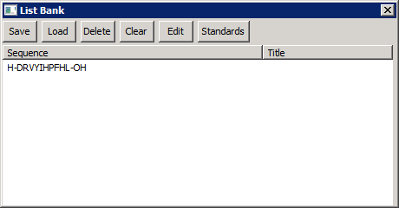

Save and load will save and load lists to/from text files. Delete will delete the selected entry. Clear will clear the list bank.

Left clicking a sequence in the list bank will send the sequence to the text box in the mzPepCalc and calculate the sequence.

Edit will allow you to go into “Edit” mode where left clicking allows you to edit the sequence or title of the item:

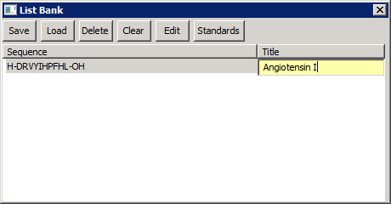

Click edit again to toggle to peptide select mode.

Clicking standards will load the file PeptideStandards.txt from the mzStudio directory. This is a handy place to store masses for commonly used laboratory peptides like angiotensin.

**MOD** will open the “Mod Manager”

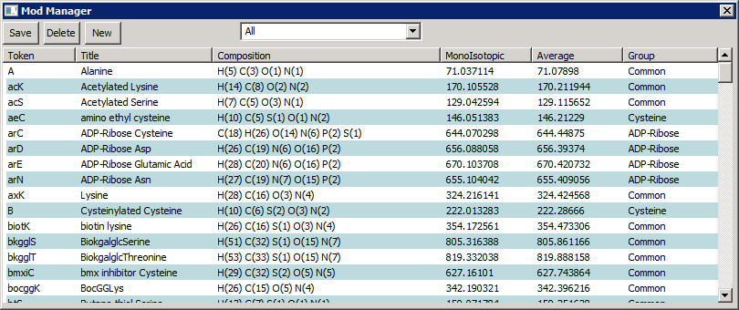

This is a list of pre-defined post-translational modifications that the mzPepCalc recognizes. For example, caC corresponds to carbamidomethyl cysteine, pS to phosphoserine, and oxM to oxidized methionine. These modifications are currently stored in a text file in the mzStudio installation directory with the path /mz_workbench/files/new_res_list.txt. Individual entries can be edited by double clicking the entry. In addition, entries can be added (New), removed (Delete) and saved (Save). Note, before new modifications are recognized, the mzStudio must be restarted.

Additionally, specific masses can be added to residues by enclosing the mass in brackets. For example, the mass of fragments for angiotensin II phosphate can be displayed by typing: DRV[97.98]YIHPF where [97.98] represents the mass of the phosphate group (H3PO4).

**Label** will label y and b ions onto the existing spectrum:

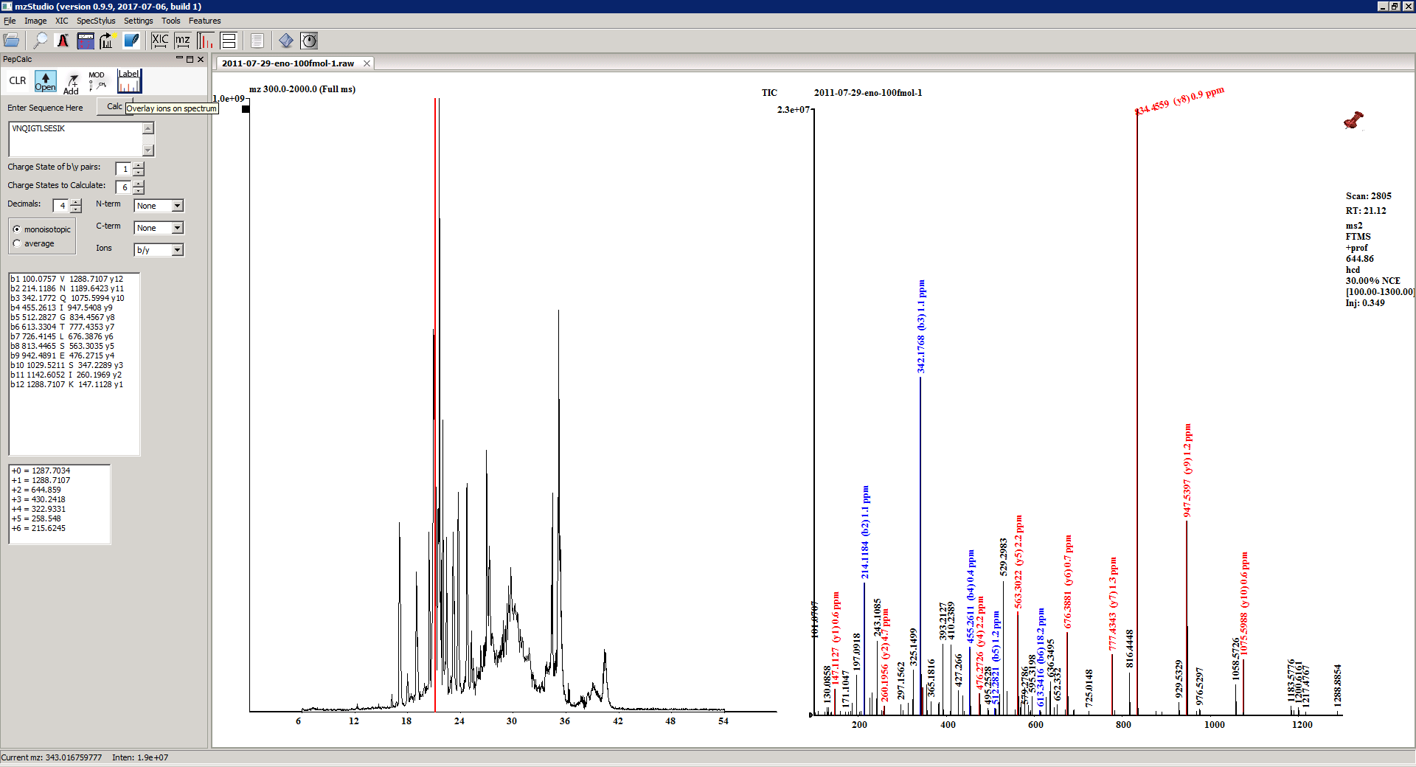

Spectrum with annotated b and y ions from label function:



From mzPepCalc, it is also possible to display XICs and locate specific product ion spectra.

Clicking on a specific calculated charge state displays a window:

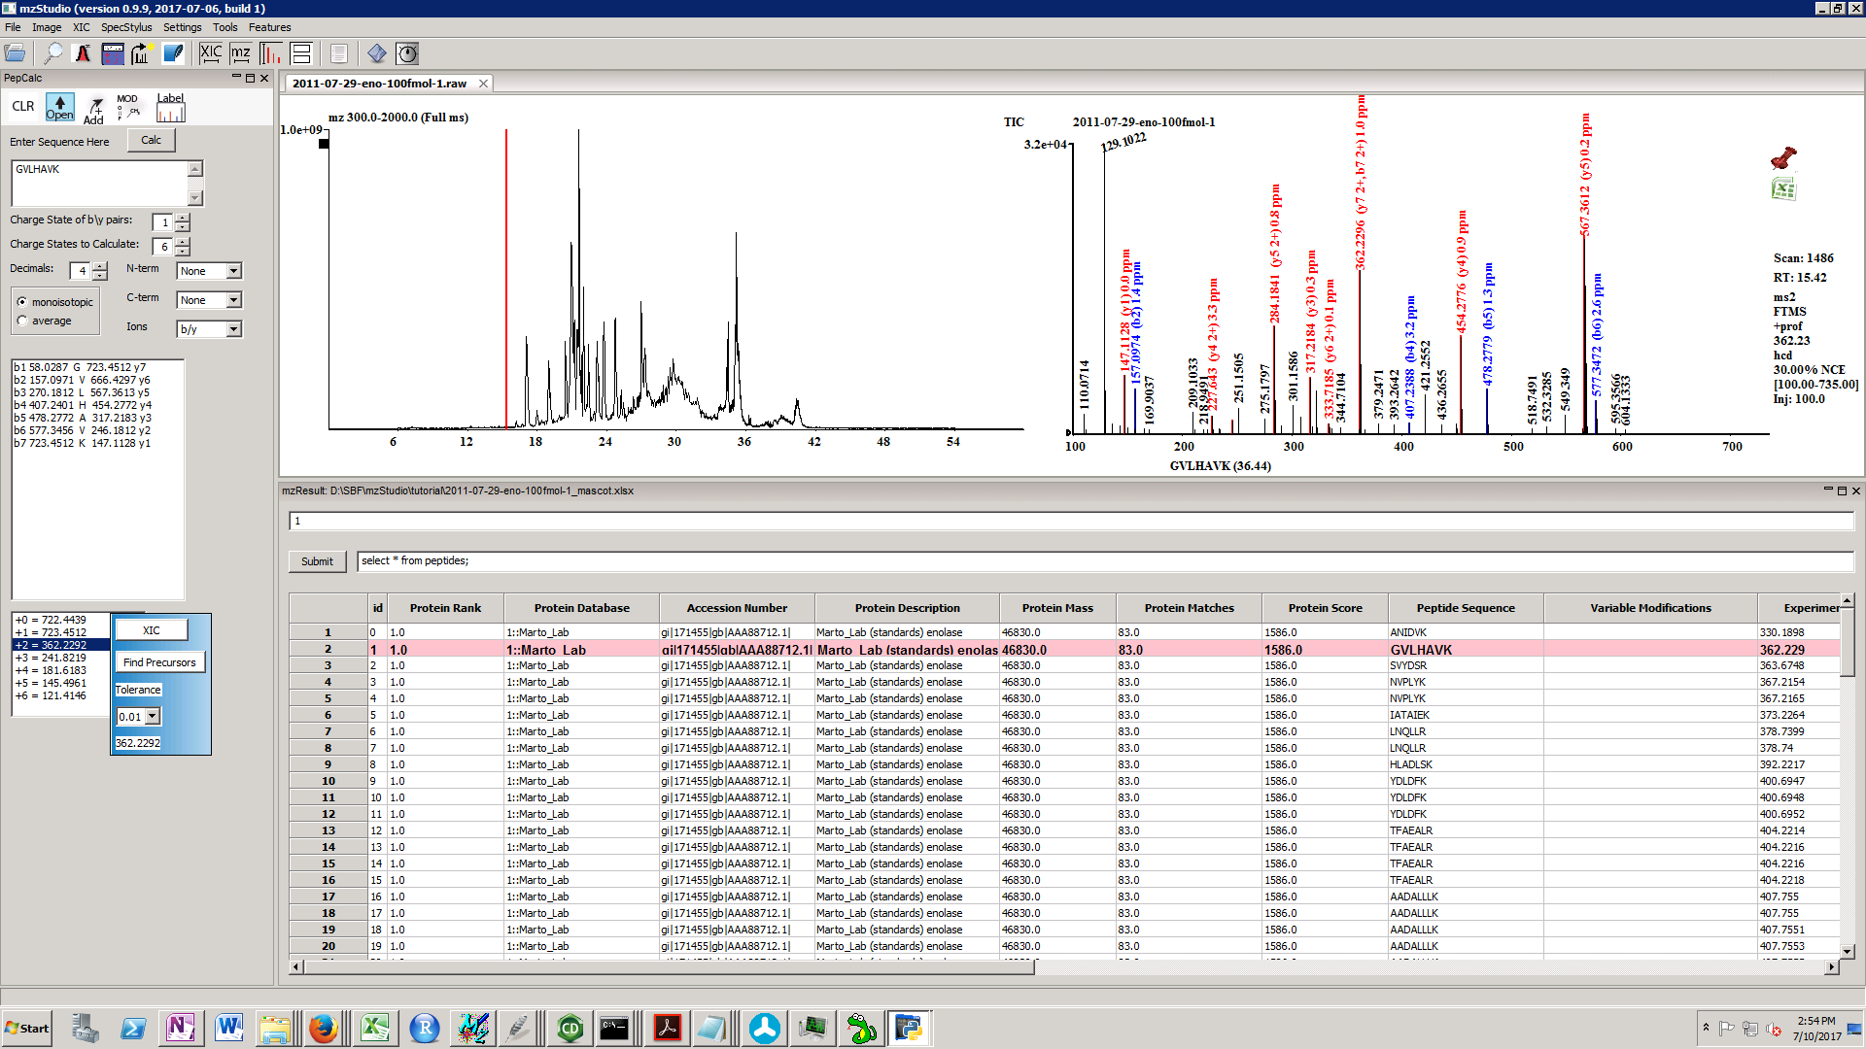

From here, XIC will display an XIC for the specified mz and tolerance, while ‘Find Precursors’ will find MS2 spectra performed on precursors of the specified mz and tolerance.

Right click in the popup window to close it.

1.  Jump to scan.

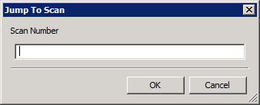

Enter scan number to navigate to this scan in the data file.

1. SQLite Icon – “Make database”.

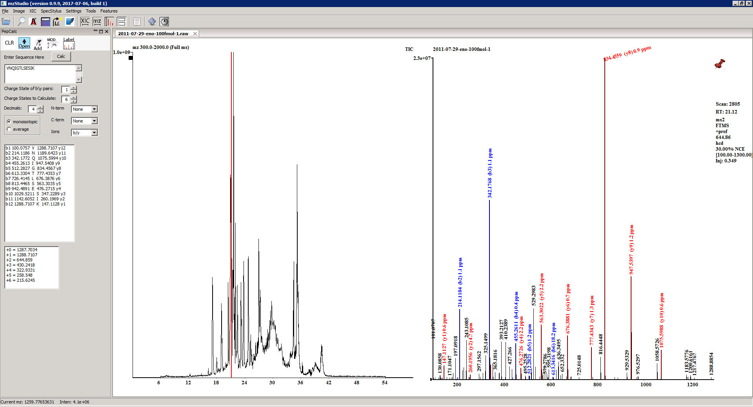

This makes a sqlite database from an xls file containing Mascot, COMET, or X!Tandem search results (in multiplierz format; see below section on “Search Result Compatibility”). All rows will be imported into a sqlite file in a table called “peptides”. All queries should be performed against this table.

It will also make a database from txt files containing Proteome Discoverer PSMs. To export the PSMs in Proteome Discoverer, select File/Export/To Text (tab delimited):

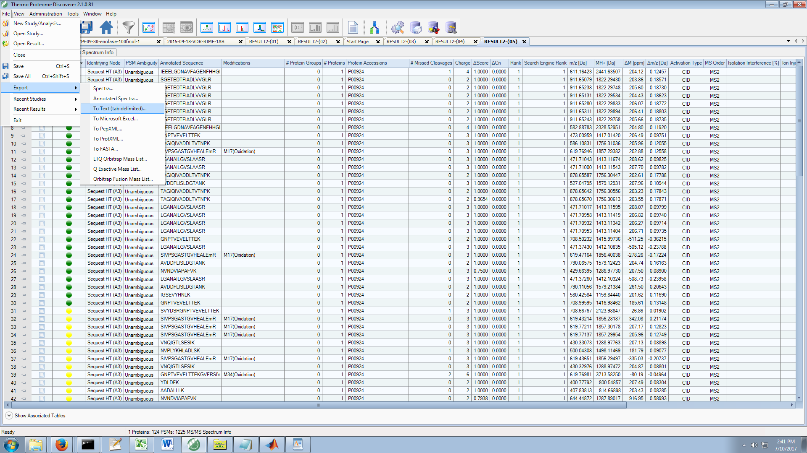

Check PSMs, then click Export. This file can then be read by mzStudio.

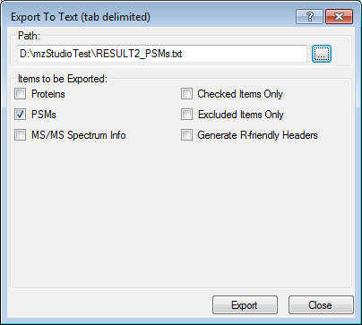

Note, when importing the Proteome Discoverer PSM file, mzStudio requires the mgf (generated by multiplierz) to lookup the scan number corresponding to each PSM (to our knowledge, this info is not exported by Proteome Discoverer; instead the “Query” or position in the mgf is listed and we look it up from here). After selecting your PSM file, just select the corresponding mgf.

The following example illustrates opening a multiplierz generated Mascot report.

Note, all search results MUST be in multiplierz format to be read correctly! mzStudio looks for specific worksheets (‘Mascot_Header’ for a Mascot Search and ‘Data’ for PSMs) and specific columns (i.e. ‘Spectrum Description’). An incorrectly formatted file will throw errors or cause unexpected behavior.

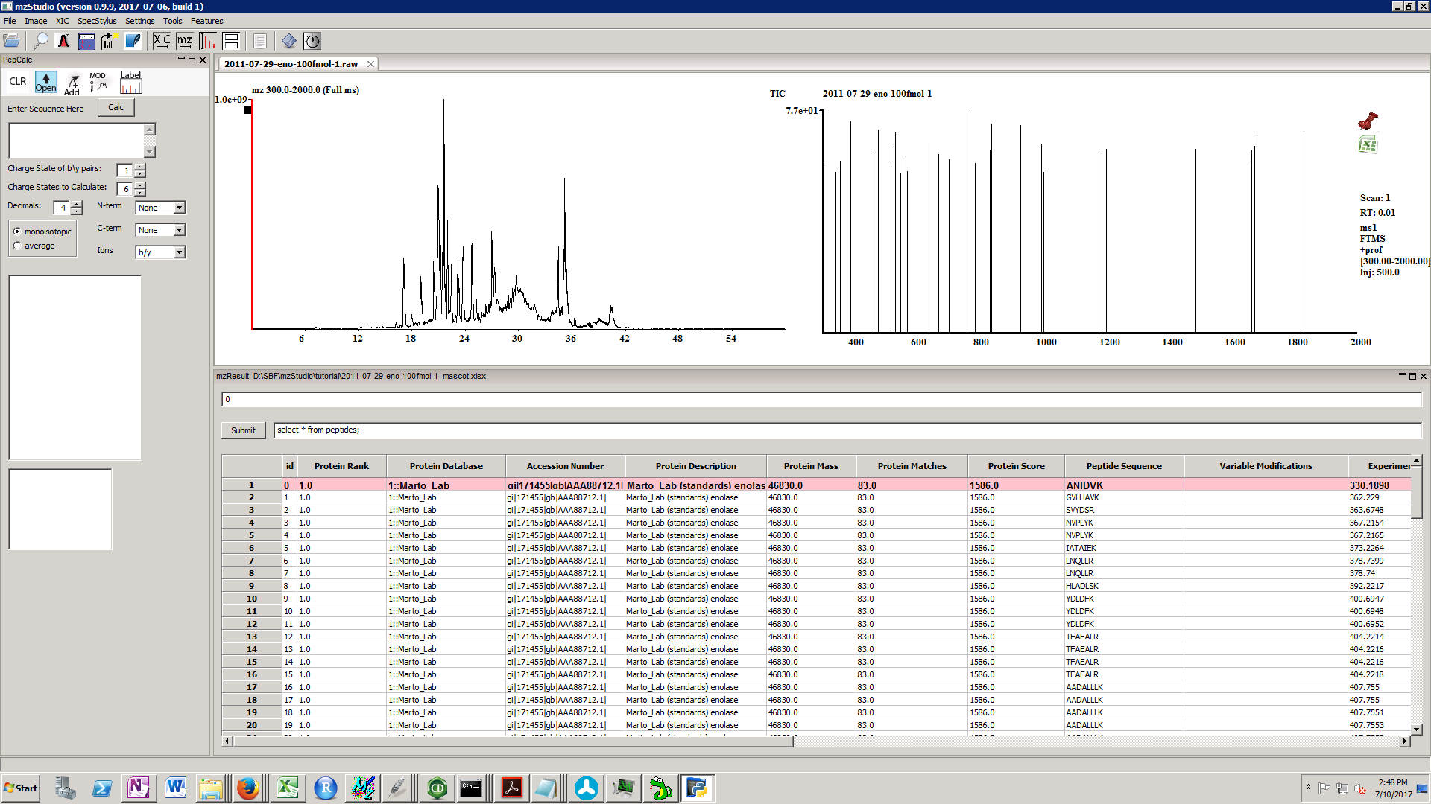

After loading the results, they are displayed in grid format. An mzPepCalc window is also opened automatically.

Clicking on a row label jumps to the selected scan and highlights that row. The sequence is displayed in the mzPepCalc sequence box and the fragment ions are calculated. In addition, fragment ions are labeled in the spectrum window.

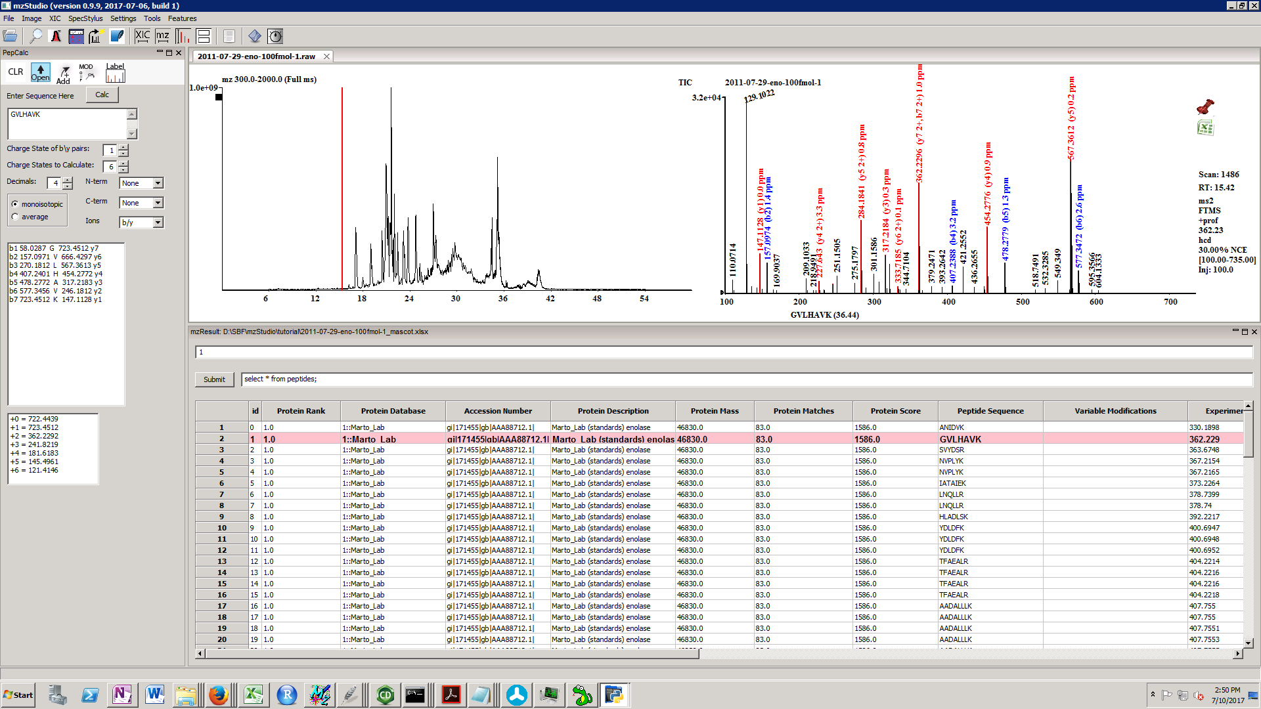

Search results may be filtered and sorted using SQLite queries. Valid queries can be entered into the text box to the right of the ‘Submit’ button, which is pressed to apply the query. The text displayed initially in this box (‘select * from peptides’) is the query used to generate the initial data table.

**Example SQLite queries:**

To sort data from highest to lowest scoring peptides, enter:

select * from peptides order by "Peptide Score" desc

and click submit.

To display only oxidized methionine containing peptides, enter:

select * from peptides where “Variable Modifications” like “%Oxidation%”

To display oxidized methionine peptides which Mascot scores > 30 and sort from highest to lowest mz:

select * from peptides where "Variable Modifications" like "%Oxidation%" and "Mascot Score" > 30 order by "Experimental mz" desc

Note the autocompletion feature of SQLITE keywords (e.g. SELECT, FROM, WHERE, etc.) which helps query construction. In addition, we implemented shortcuts for common worksheet column names; when these keys are typed, they will be replaced in-line with the following column names:

~var Variable modifications

~sc Peptide score

~gn Gene name

~desc Protein Description

~acc Accession

~lk “LIKE %%”

~xc “Cross correlation”

~ex Expect

~seq Peptide Sequence

***Search Result Compatibility***

To correctly load search results, interpret modifications, and navigate scan information, Mascot, COMET, and X!Tandem results should be in multiplierz format. For more information on using multiplierz/mzDesktop, please refer to the wiki pages:

<https://github.com/BlaisProteomics/mzDesktop/wiki>

<https://github.com/BlaisProteomics/multiplierz/wiki>

Basically, mzStudio requires a header worksheet listing fixed modifications (variable mods are usually listed with the PSMs). In addition, mzStudio looks for a column called “Spectrum Description” with a specific format that it can parse the scan number.

1.  ***Set XIC time range***

Opens dialog to set the displayed time range. Enter start time, stop time or start time – stop time.

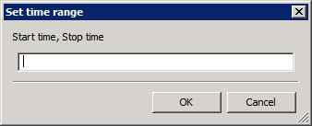

1.  ***Set spectrum m/z display range***

Opens dialog to set the displayed m/z range. Enter Start mz-stop mz to display the range, or Center, Width to center on an m/z with the selected width.

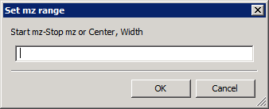

1.  ***Set Spectrum Intensity Scale***

Opens dialog; allows spectrum to be re-scaled to the specified intensity.

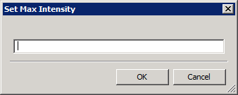

1. 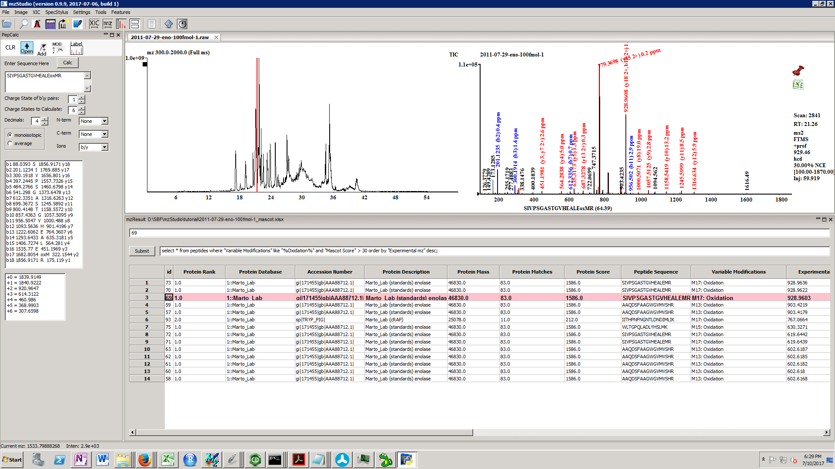 ***Toggle for XIC traces (new window vs. overlay)***



This button toggles how new XIC traces are added to the main XIC window. By default, they are displayed in new windows; this button toggles to allow new traces to overlay the last window.

1.  ***View spectrum list***

Displays the current spectrum in text format. Can be copied to clipboard with Ctrl-V.

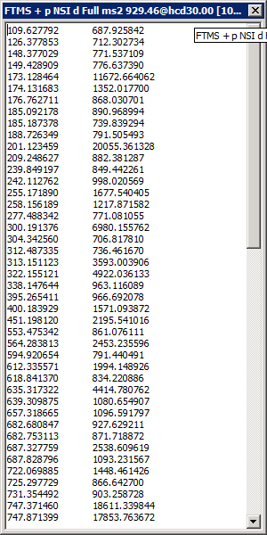

1.  ***Perform Spectrum Search***

This button will perform database search of the currently displayed spectrum, via the *multiplierz* search interface. It uses the algorithm that is selected in the Settings page (Settings/Change Settings). The default search algorithm is set to Mascot. Comet and X!Tandem can also be selected. Note, all search algorithms should be installed and correctly configured in your *multiplierz* settings file prior to use (see sections below “Installing COMET, X!Tandem” and “Configuring Comet, X!Tandem and Mascot for use with mzStudio“ .

For a Mascot search, login with your credentials:

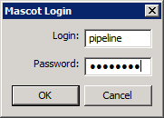

Enter your search parameters:

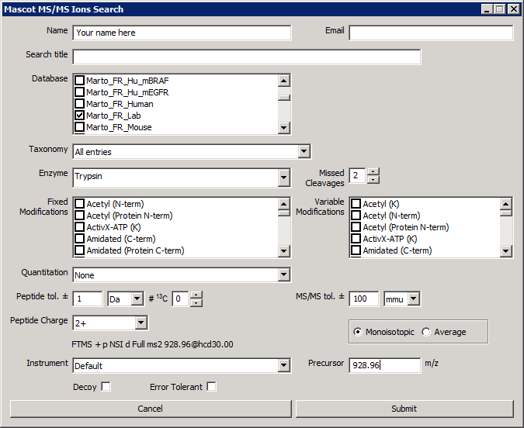

If there is a significant hit, it will be sent to mzPepCalc and annotations will appear in the spectrum window:

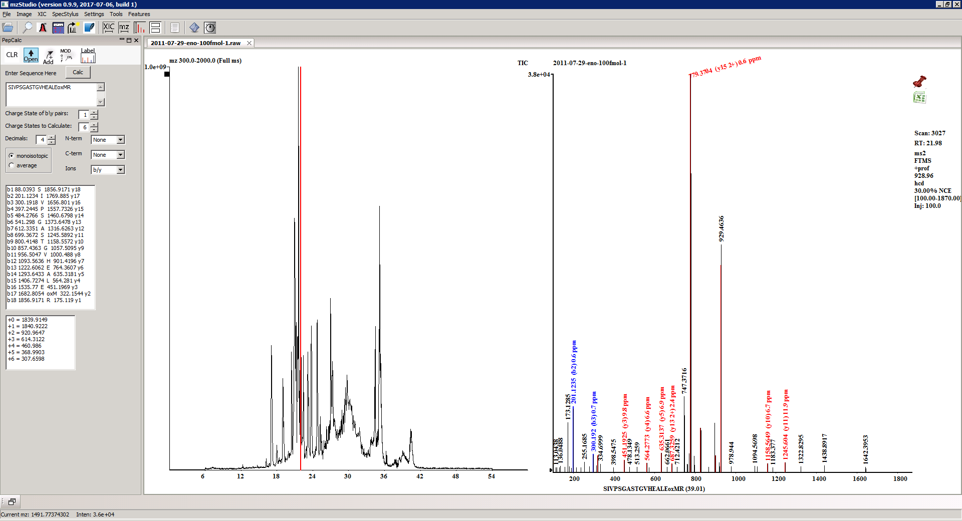

1.  ***Set fragment ion label tolerance***

This sets the tolerance for labeling fragment ions. Entering ‘0’ uses the instrument default (0.02 Da for FTMS instruments, 0.5 Da for all others).

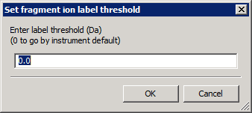

***Extracted Ion Chromatograms***

To perform extracted ion chromatograms, click XIC/XIC.

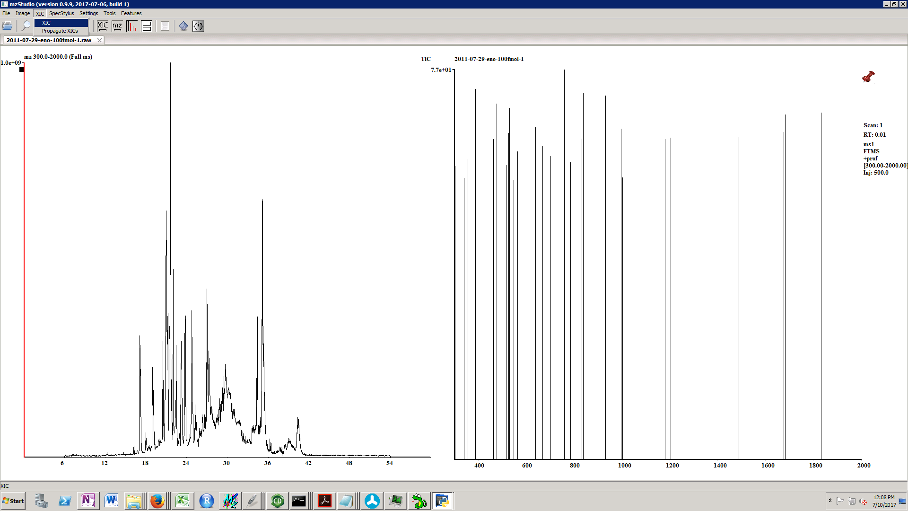

This opens the XIC window.

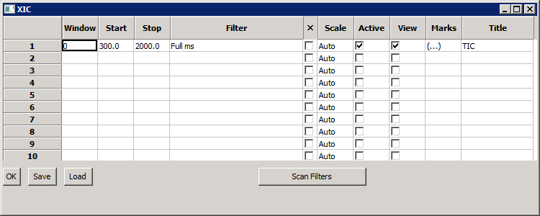

To create a new XIC, click in the next available row (row 2 in this case). By default, the XIC is assigned to the next available “Window” meaning the data will appear in a new trace. By setting this to 0, both traces would be overlaid.

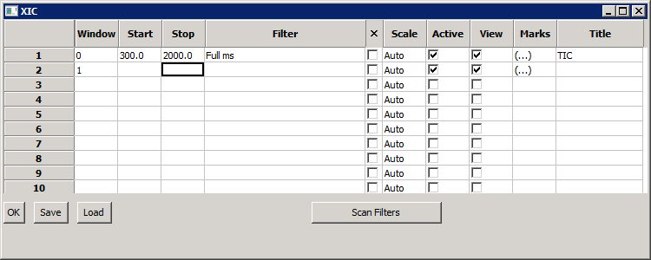

After entering parameters, hit OK.

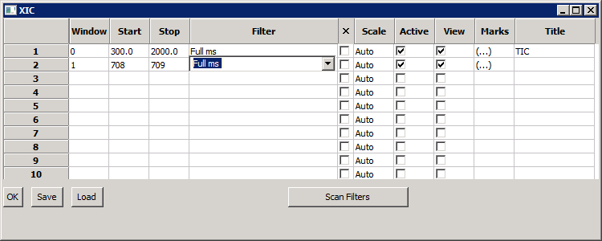

The new XIC is displayed.

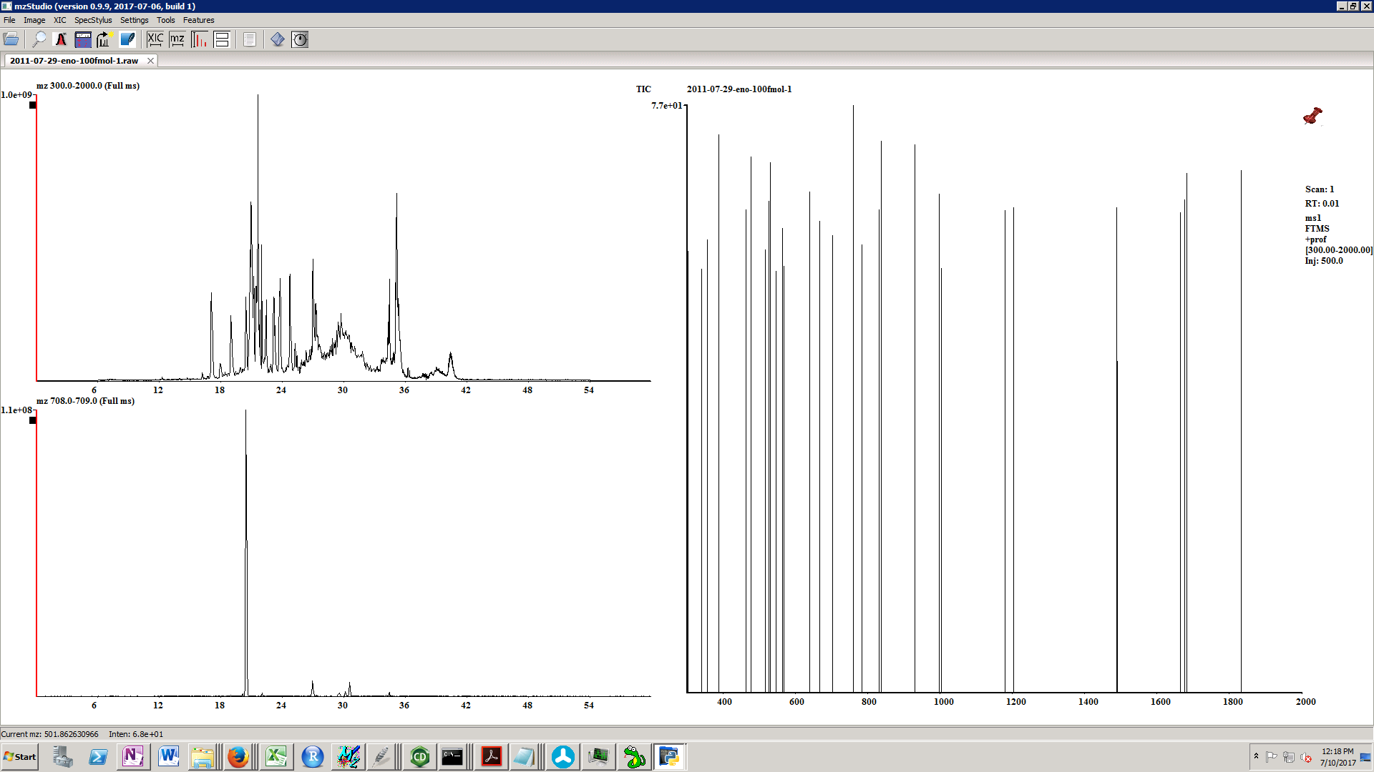



“Save” and “Load” are used to save and load the contents of XIC windows in text format.

“Scan Filters” will detect non-data dependent MS2 scans (i.e. targeted MS2 scans from appropriate experiments).

To delete an XIC, click the tab on the upper left of the window (or click in the X column in the XIC window).



The “Filter” indicates the type of data that will be selected for display. For example, one can choose MS1 data, MS2 data, or all data (for all data, the filter should be null or nothing entered). By default, Full MS and Full MS2 can selected from the combobox (or MGF ms2 for mgf files). Additional filters can be entered manually. To populate the combo box with targeted MS2 scans, hit the “scan filters” button. XICs can be deleted by selecting the “X” check box. Several types of scaling are possible. “Auto” automatically scales each chromatogram according to its maximum value. To scale a trace to another, enter “sX” where X corresponds to the window number to scale against. For example, to scale window 0 to the maximum intensity of window 1, s1 should be entered as window 0’s (row 1’s) scale parameter. Enter “max” to scale each XIC to the maximum of all displayed.

XICs can also be overlaid by left click and drag from one window to another:

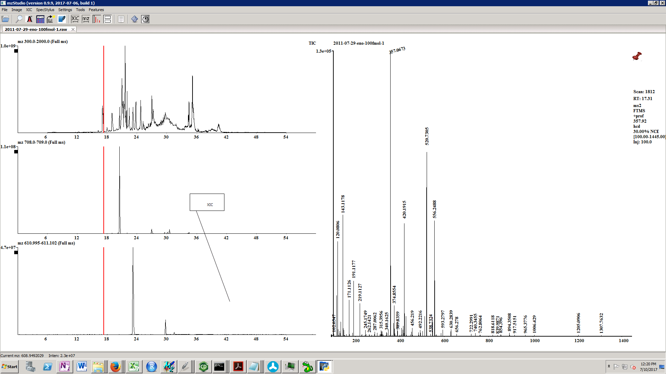

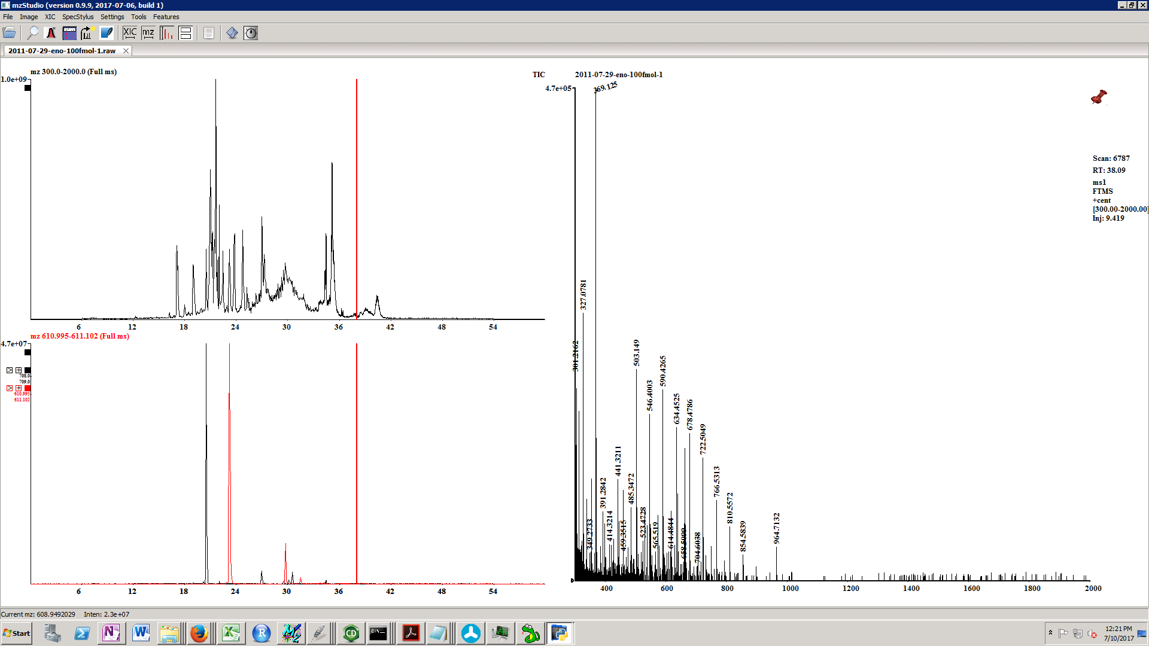

Tab layout for overlaid windows:



Note the tabs that are displayed to the left of the XIC. Left click on the solid upper tab will delete the entire set of XICs. Additional sets of tabs are displayed for each XIC displayed in the window. Left click on the solid tab will make the trace “Active” – the apex intensity for this trace will appear to the left of the window, and the extracted mass range will appear above the window (in this example, two traces are displayed; XIC 610.995-611.102 is displayed in red; its max intensity is 4.7E7 counts). In addition, if peak integrations are perform, they will be performed on the active window. The +/- tabs are used to view/hide individual traces. The active trace cannot be hidden. The ‘>’ is used to send the individual trace to its own individual window.

Another useful feature in the ‘XIC’ menu is ‘Propagate XICs’. This will display the same set of XICs for each data file that is currently open.

**Extracted Ion Chromatograms for Wiff files**

When wiff files are loaded, the different scan types in the data file are determined and will be entered as defaults in the filters combo box. These can be selected to perform XICs specific to particular scans.

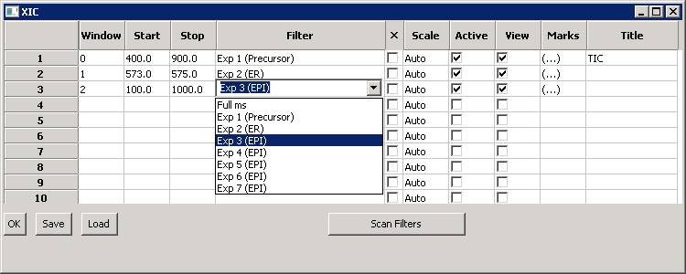

***Image Menu***

To export images

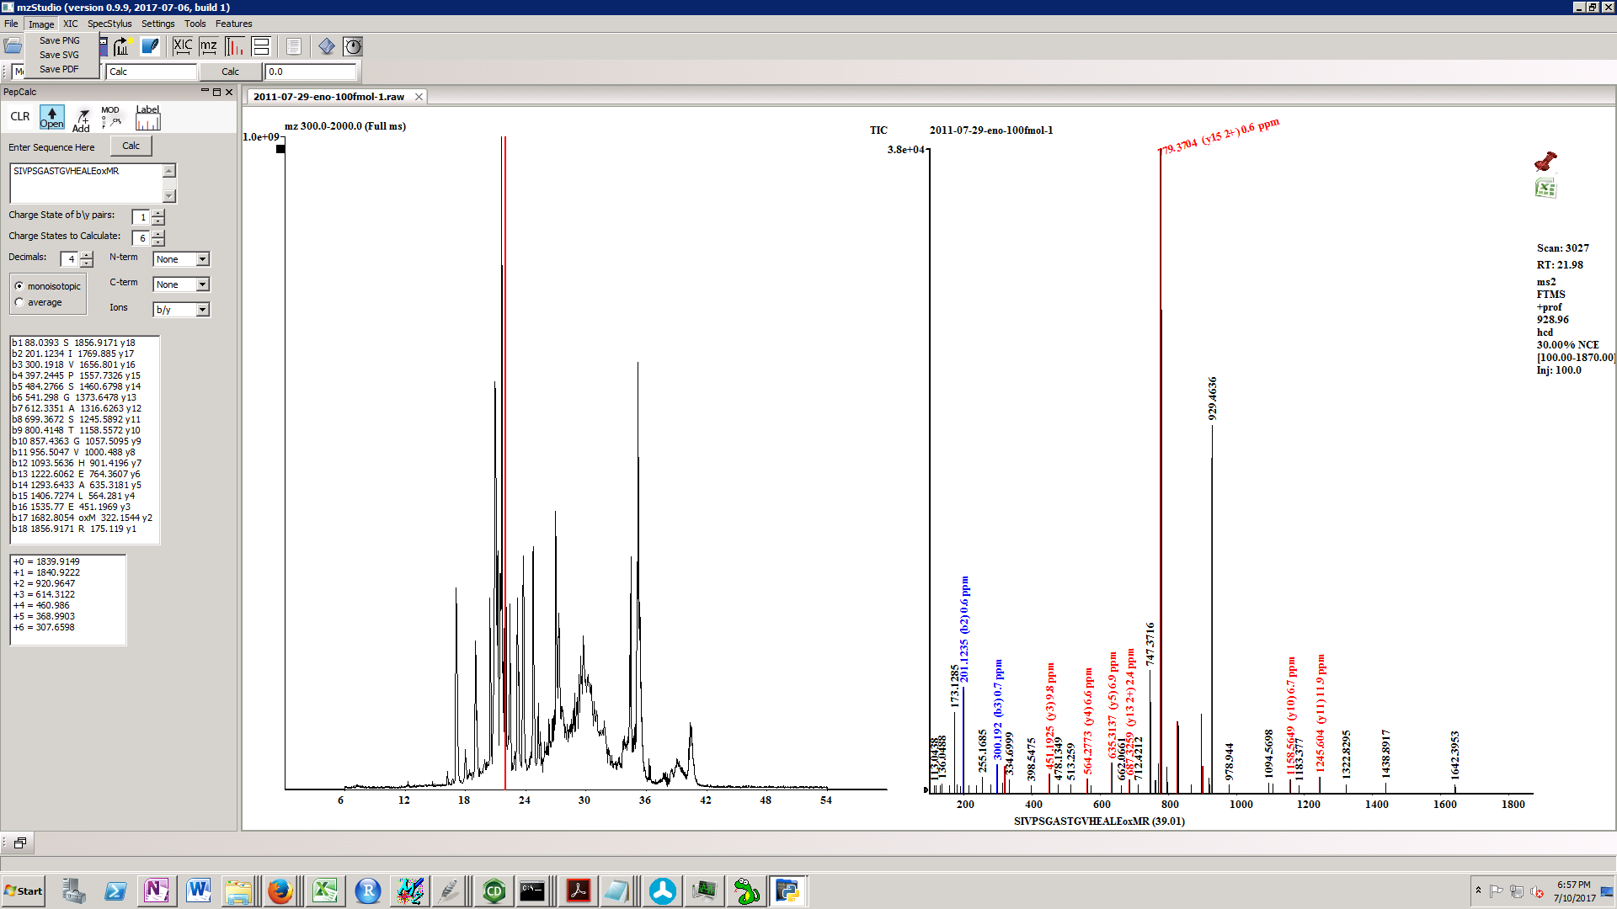

Select the image type, browse to the location, and type the filename.

***Tools Menu***

In the tools menu, three useful tools are available:

(1) miniCHNOPS: Enter a formula in the first text box, select Monoisotopic or average from the combo box, click the calc button, and the molecular weight appears in the second text box. Accepted formats are C3 or C(3) for 3 carbons.

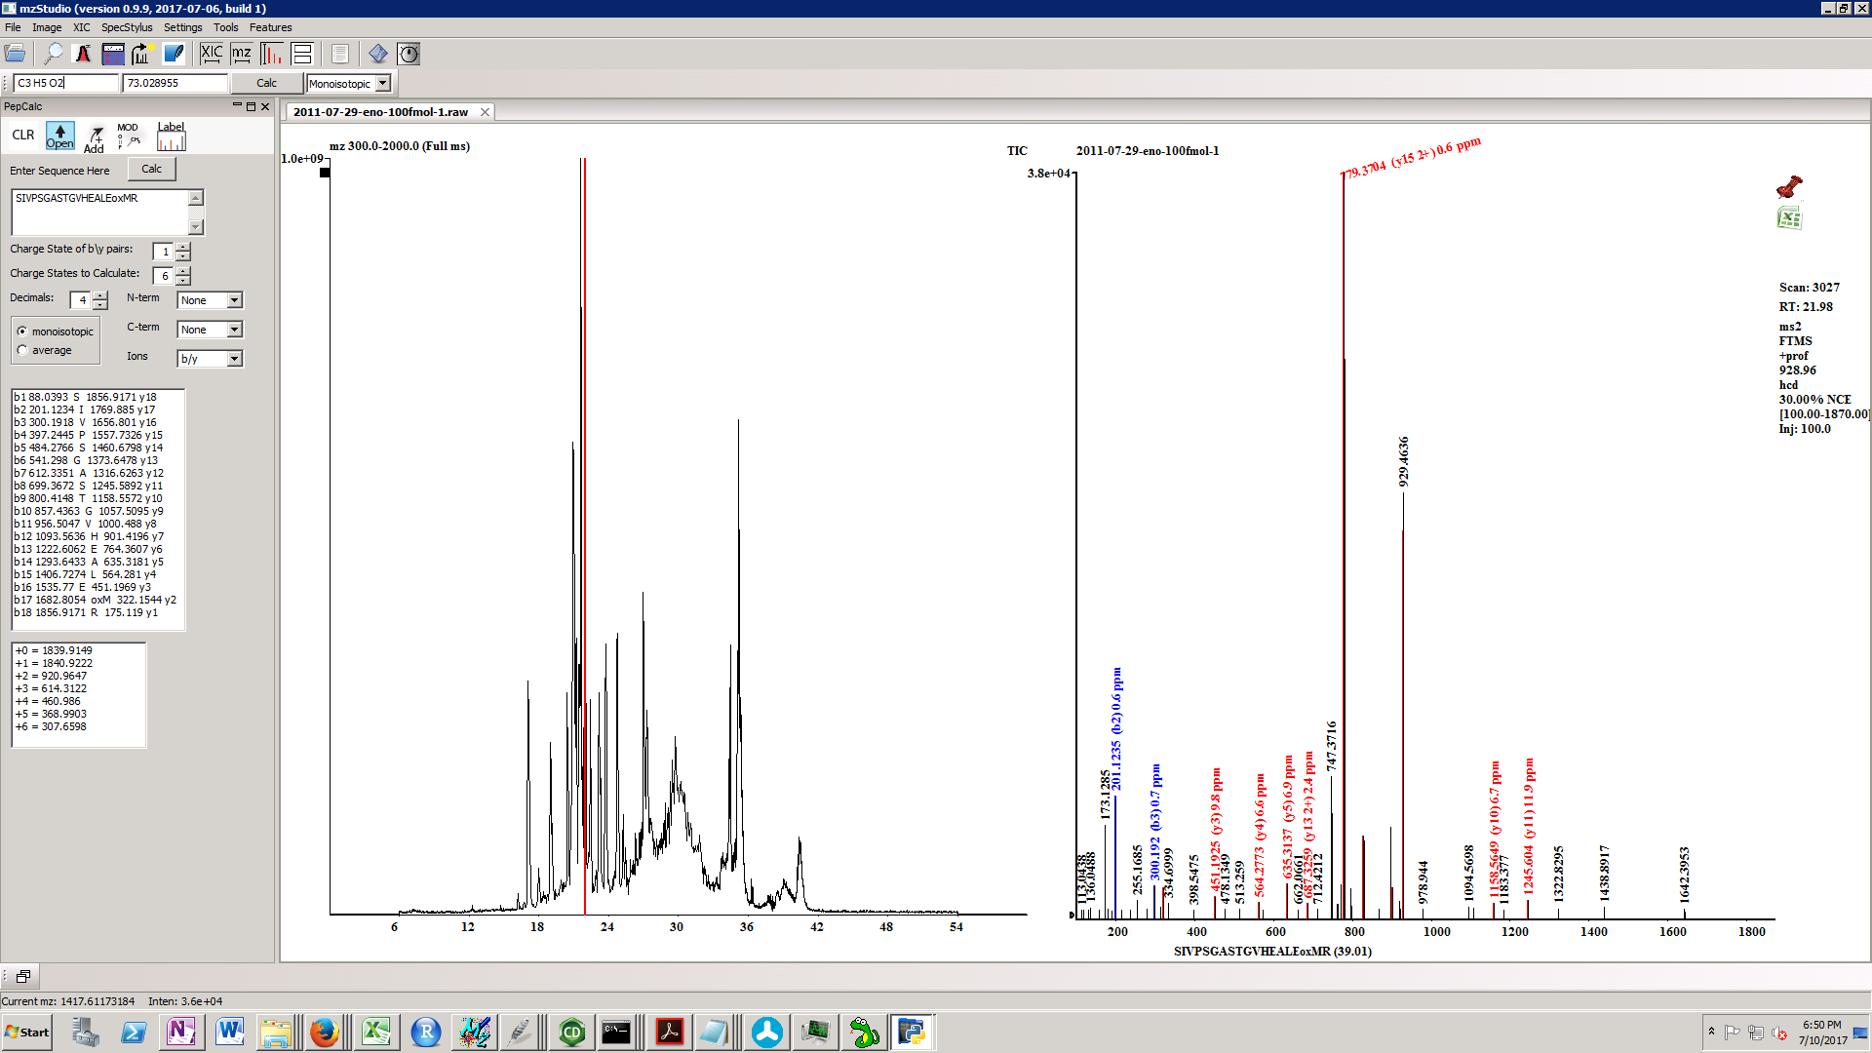

(2) areaBank: When this tool is open, all manual integration results (Right click, drag in XIC window) are appended to the text box. ‘Copy’ puts the results on the clipboard for pasting into applications like excel. Clear to reset.

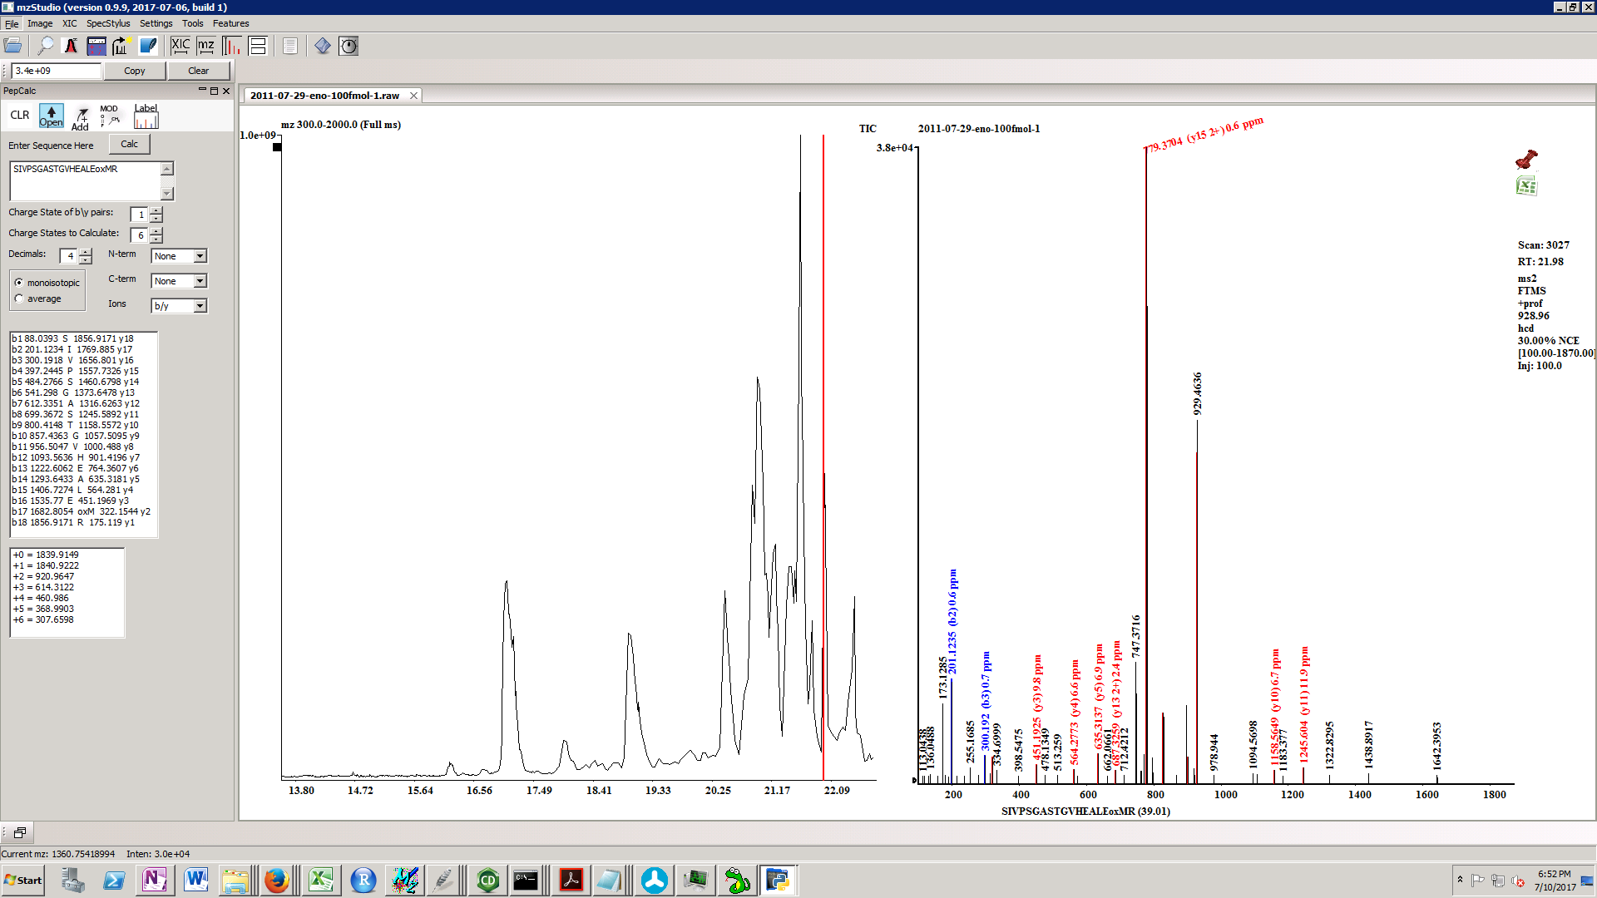

(3) Mass accuracy calculator: Enter measured and calculated masses in the indicated text boxes, and pressing the calc button will display the ppm error in the rightmost textbox.

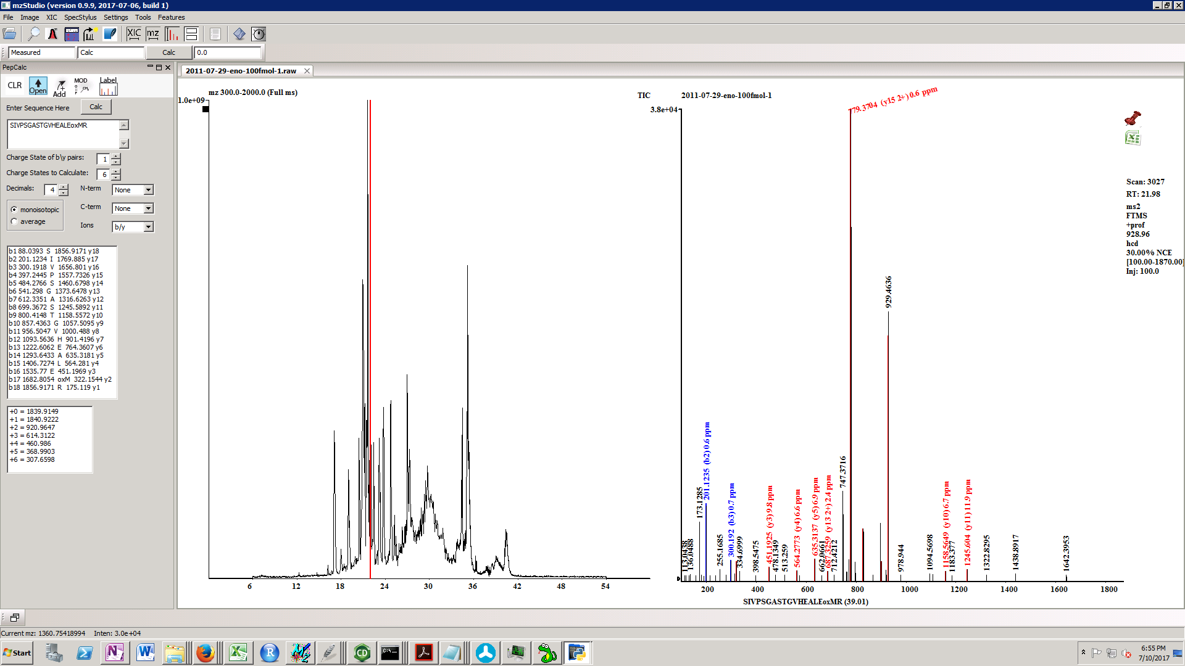

***SpecStylus Menu***

Click ‘Open Specstylus’ to open an instance of the spectral notebooking and annotation tool.

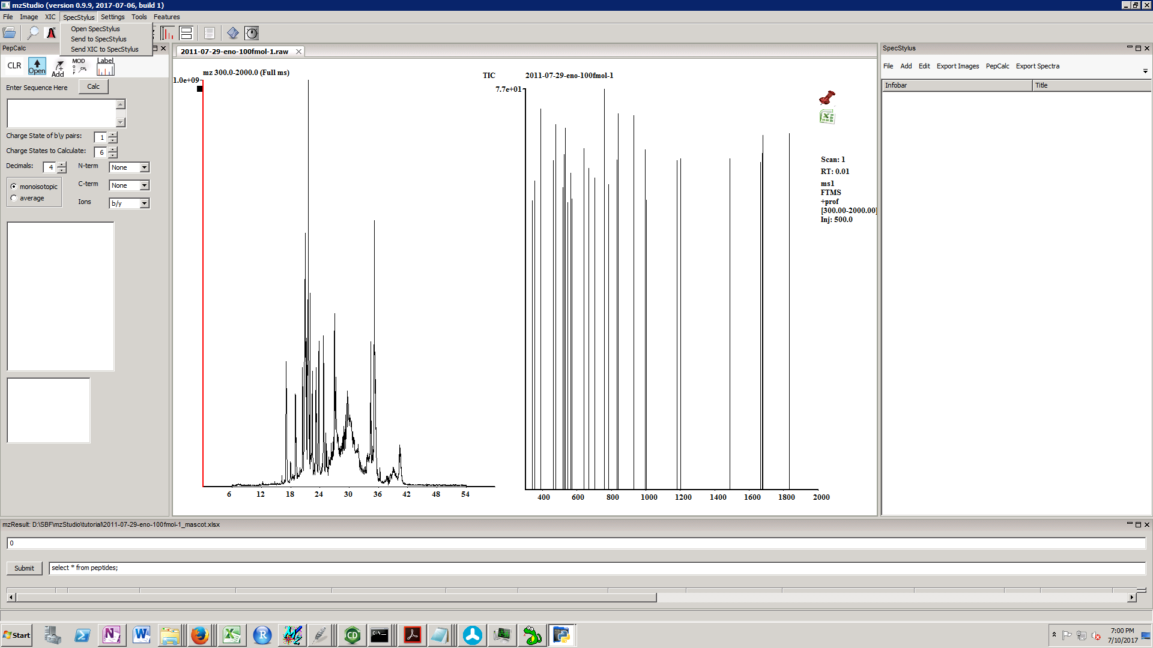

To create a new notebook, click File new and enter the notebook name.

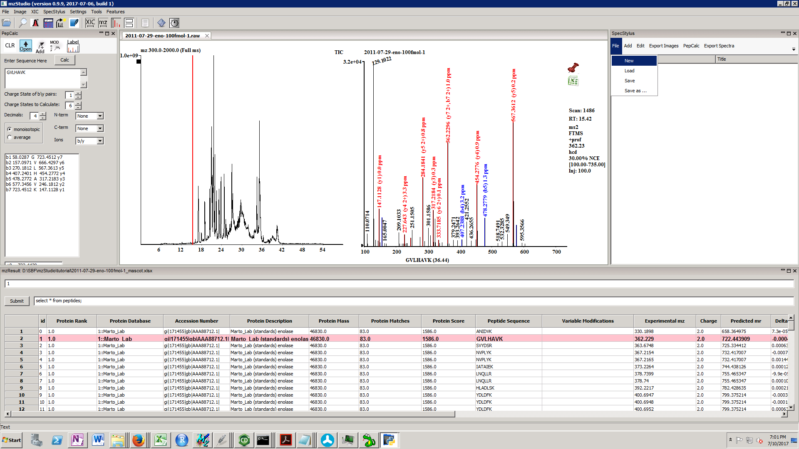

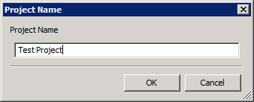

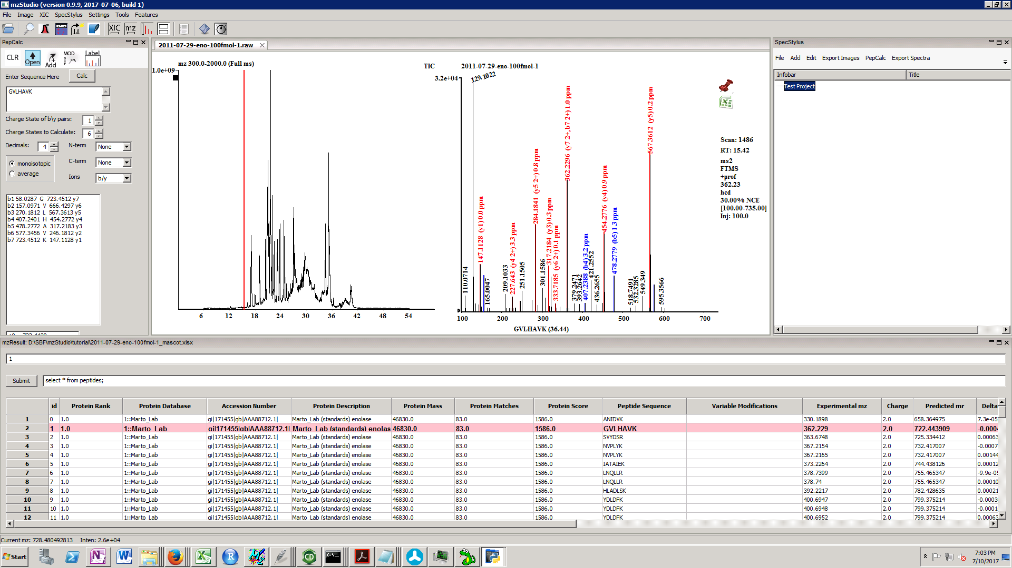

To add a new folder, click Add/New folder.

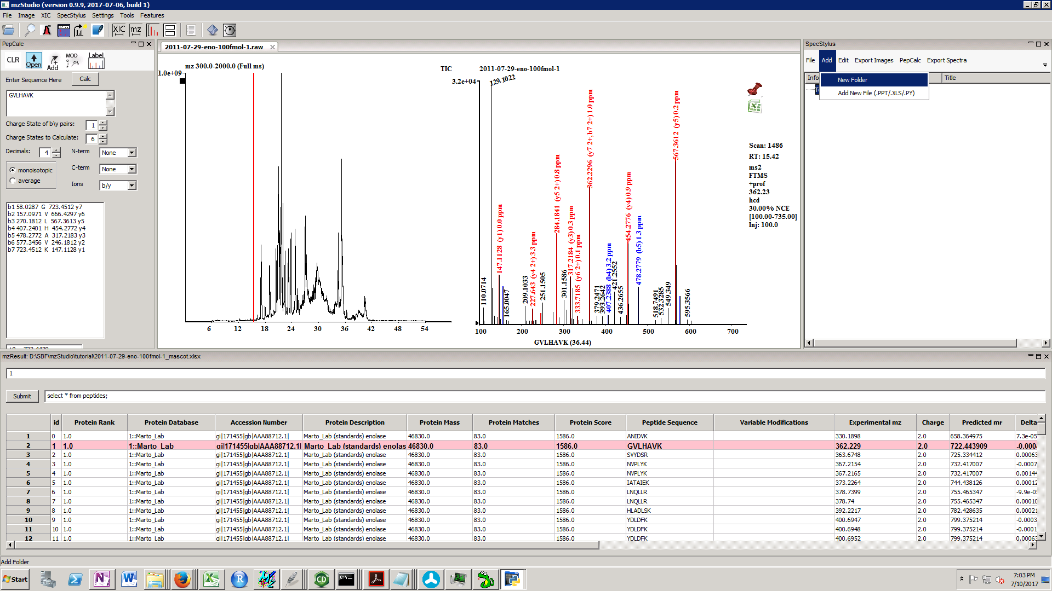

This adds a new folder to the selected node.

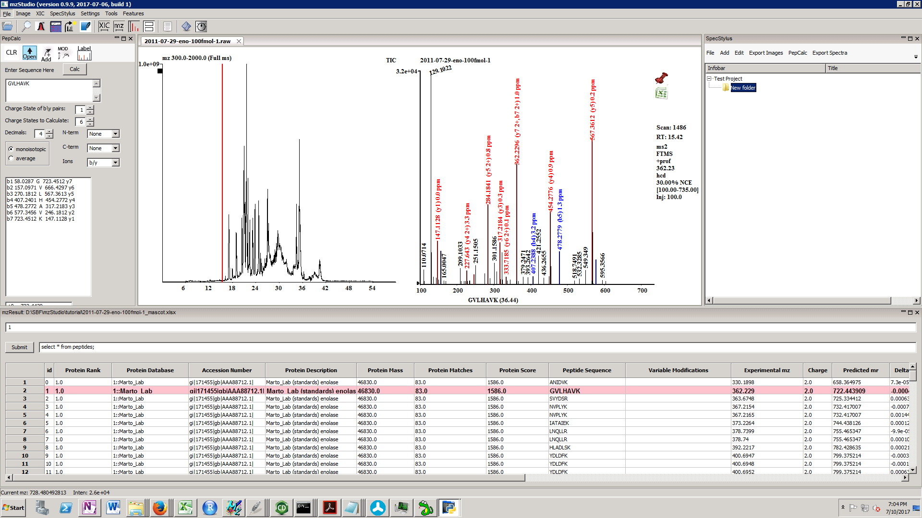

To set the filename, select the newly added folder and right click in the window. Select ‘Edit Info Bar’.

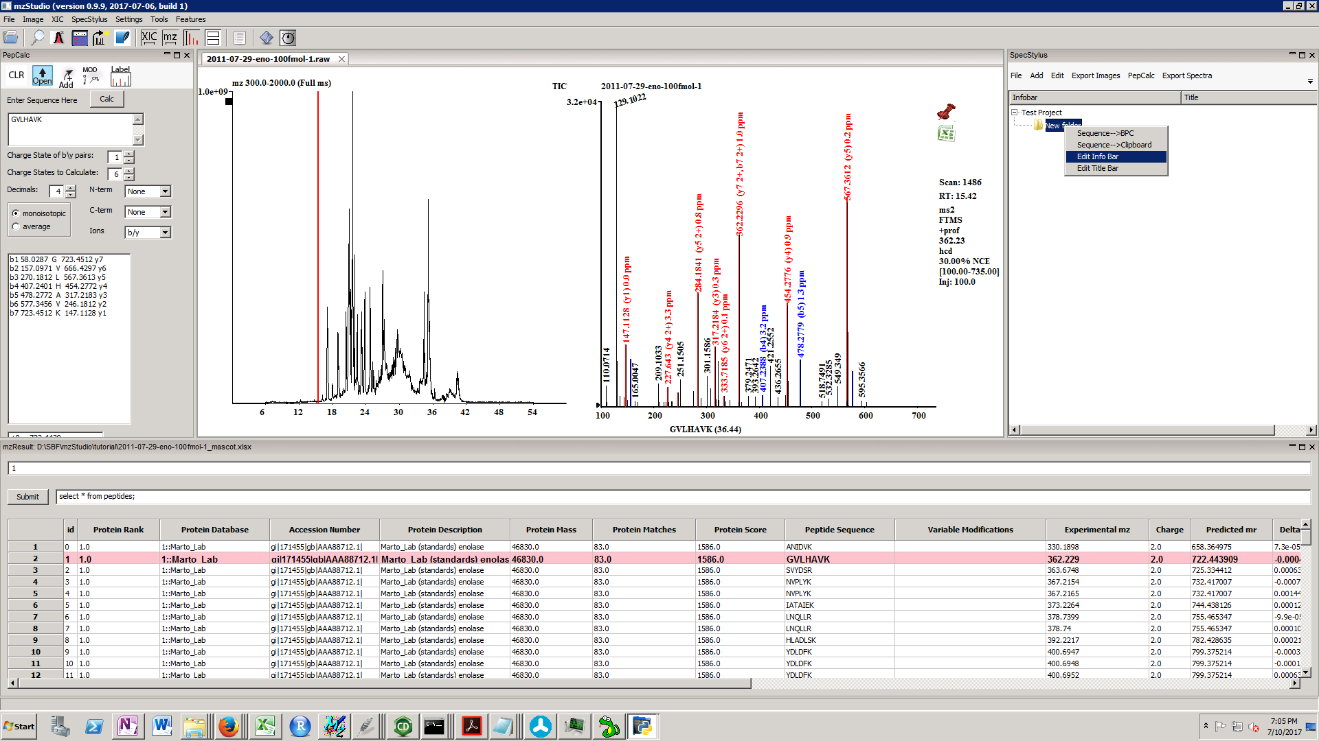

Enter the filename and hit enter.

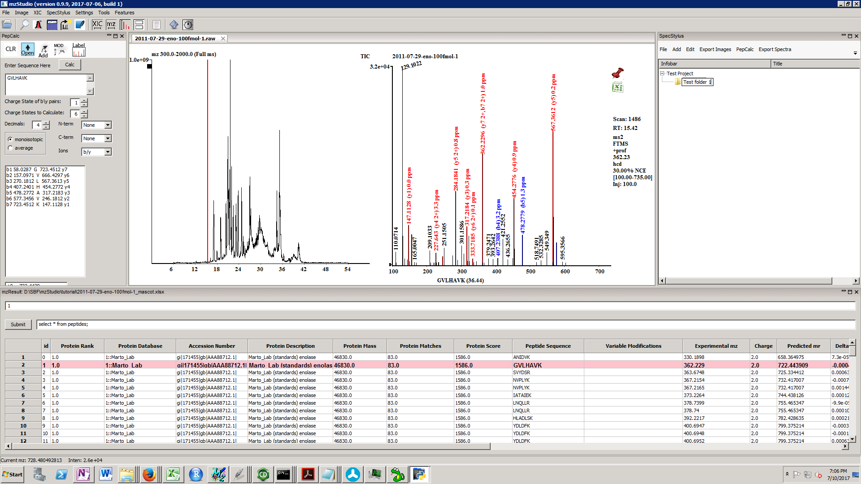

Spectra and XICs can be added to the SpecStylus by holding down CTRL key, left clicking in the spectrum or XIC window, dragging to the SpecStylus window and dropping it there. They will be added to the selected node.

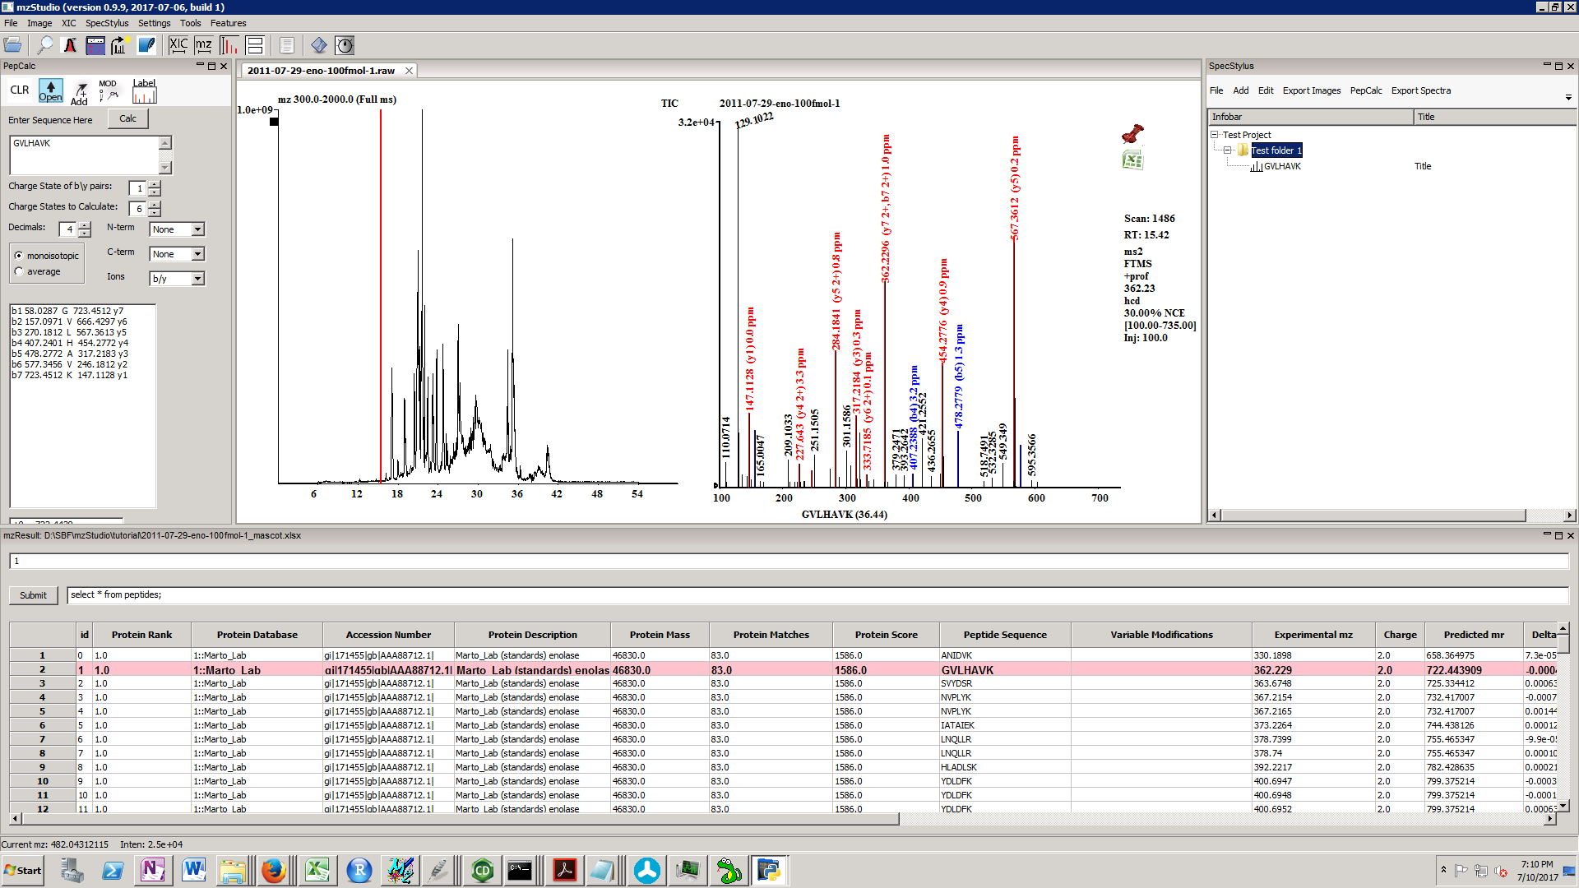

The title can be changed by selecting the spectrum, right clicking in the window, and selecting edit title bar.

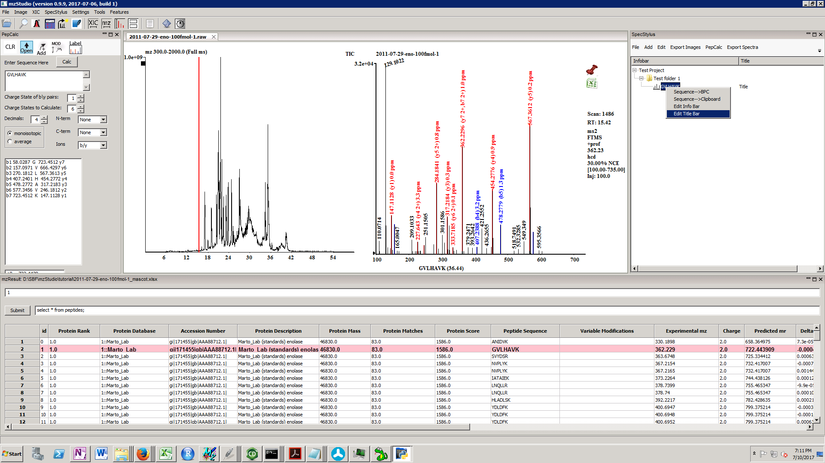

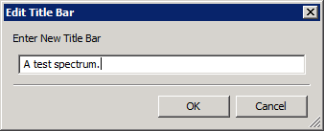

Nodes can be rearranged by selecting the item, and then left clicking and dragging to a new location.

Powerpoint, excel, and python files can be imported into the SpecStylus by drag and drop from the Windows explorer.

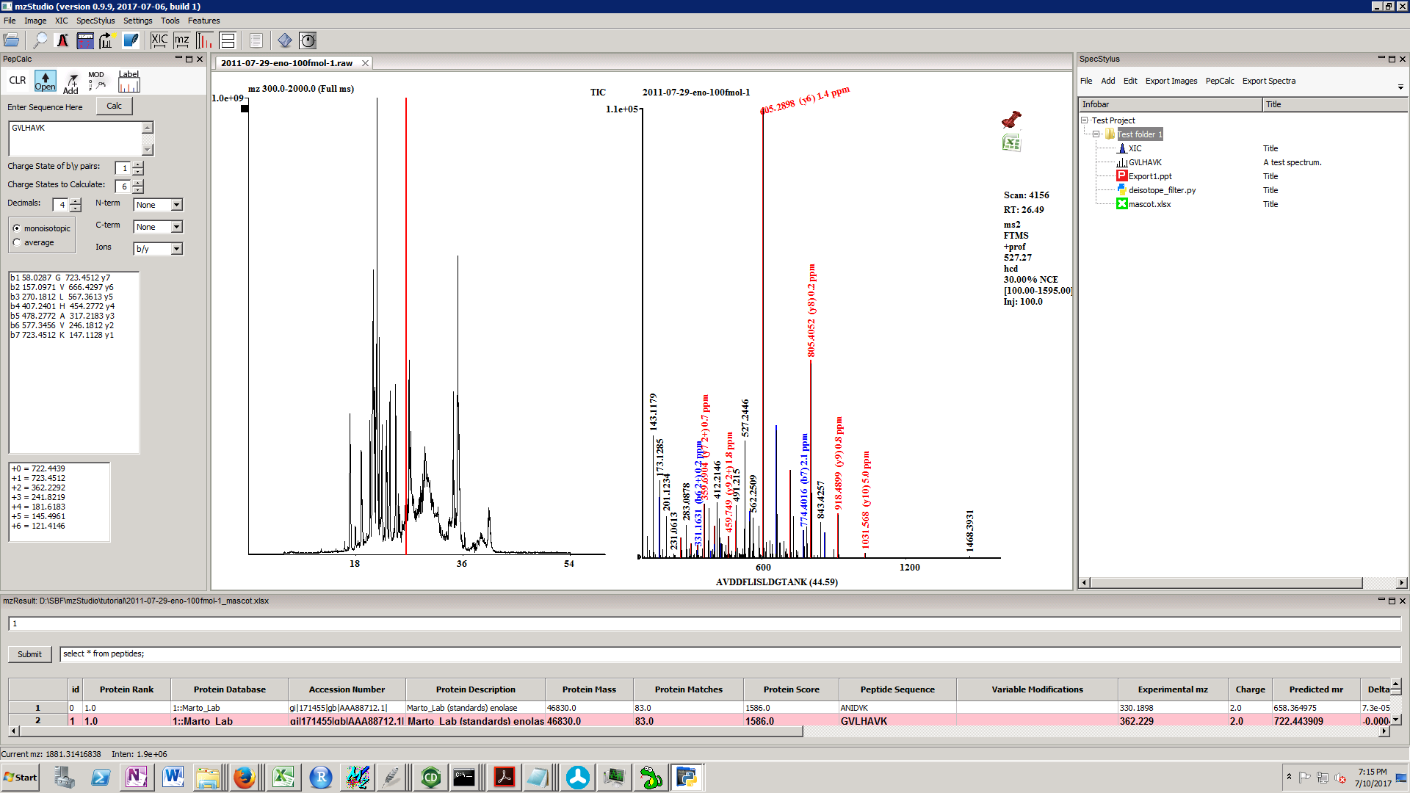

Double clicking each item opens it.

XICs are displayed in ‘XICview Lite’.

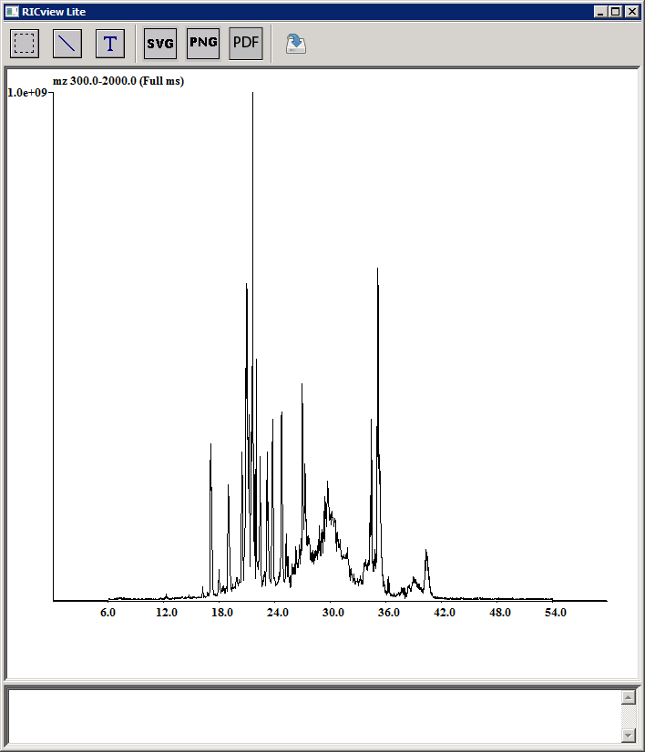

Here, XICs can be annotated with lines and text by selecting the appropriate widget and drawing the line, or clicking where to place the text.

In addition, notes can be entered in the lower text box.

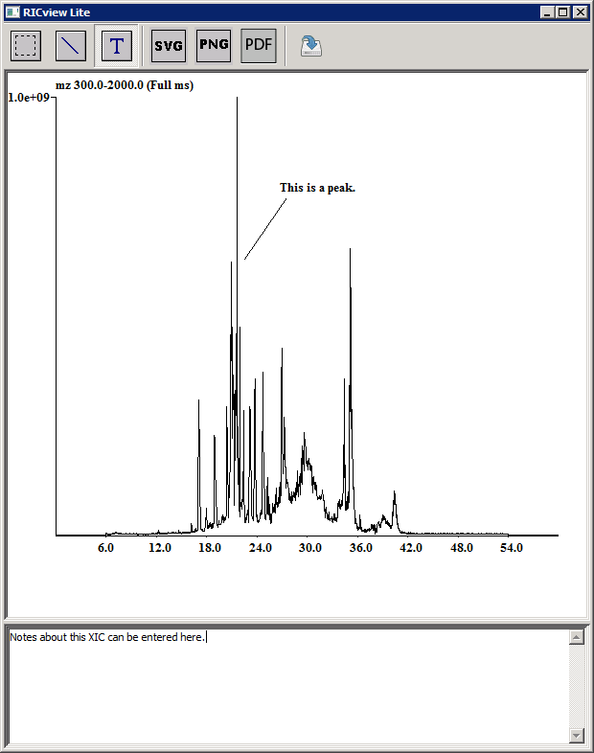

Save button saves the XIC and all annotations. Select allows selecting objects; they can be deleted with the delete key, or repositioned with the mouse. Images can be exported with the SVG, PNG, or PDF buttons.

When a spectrum is dragged to the SpecStylus, associated sequences and annotations are retained. The SpecViewLite toolbar has options for drawing lines, adding text, saving annotations, and exporting images. The mz tool allows zooming to a specific mass range. Typing 1, 2, or 3 will split the mass spectrum on the specified number of x-axes. If this is a processed spectrum (i.e. a custom spectrum processing script was applied to raw data), toggling ‘Q’ will turn processing on/off. The last tool sets the fragment ion label tolerance. Entering ‘0’ uses the instrument default (0.02 Da for FTMS instruments, 0.5 Da for all others).

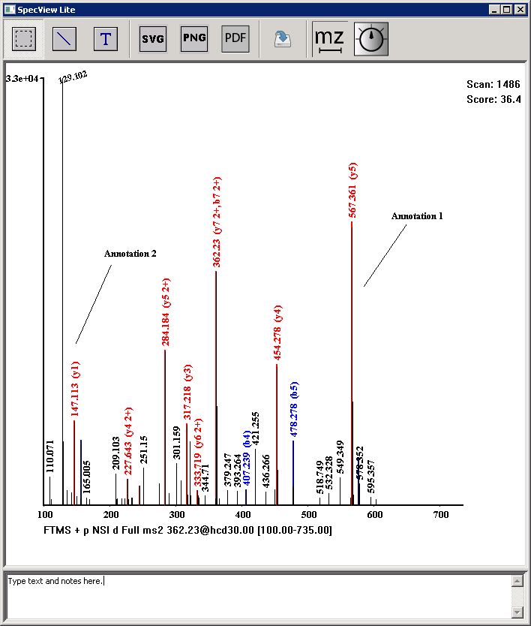

Opening a python script sets it as the currently active “Spectrum Processor”. This is discussed in more detail in the custom script section below.

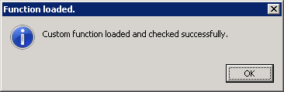

Specstylus menu items:

File – create new SpecStylus notebook, load and save notebooks.

Add – adds a new folder, or auxiliary file (ppt, xls, py) to the selected node.

Edit – edit or delete item.

Export images – can export the current XIC or spectrum to ppt, or all spectra and XIC to powerpoint.

PepCalc – open mzPepCalc

Export Spectra – Makes a NIST compatible spectral library that can be used with the NIST search tool.

***Settings Menu***

***Change settings*** – allows a range of options to be selected.

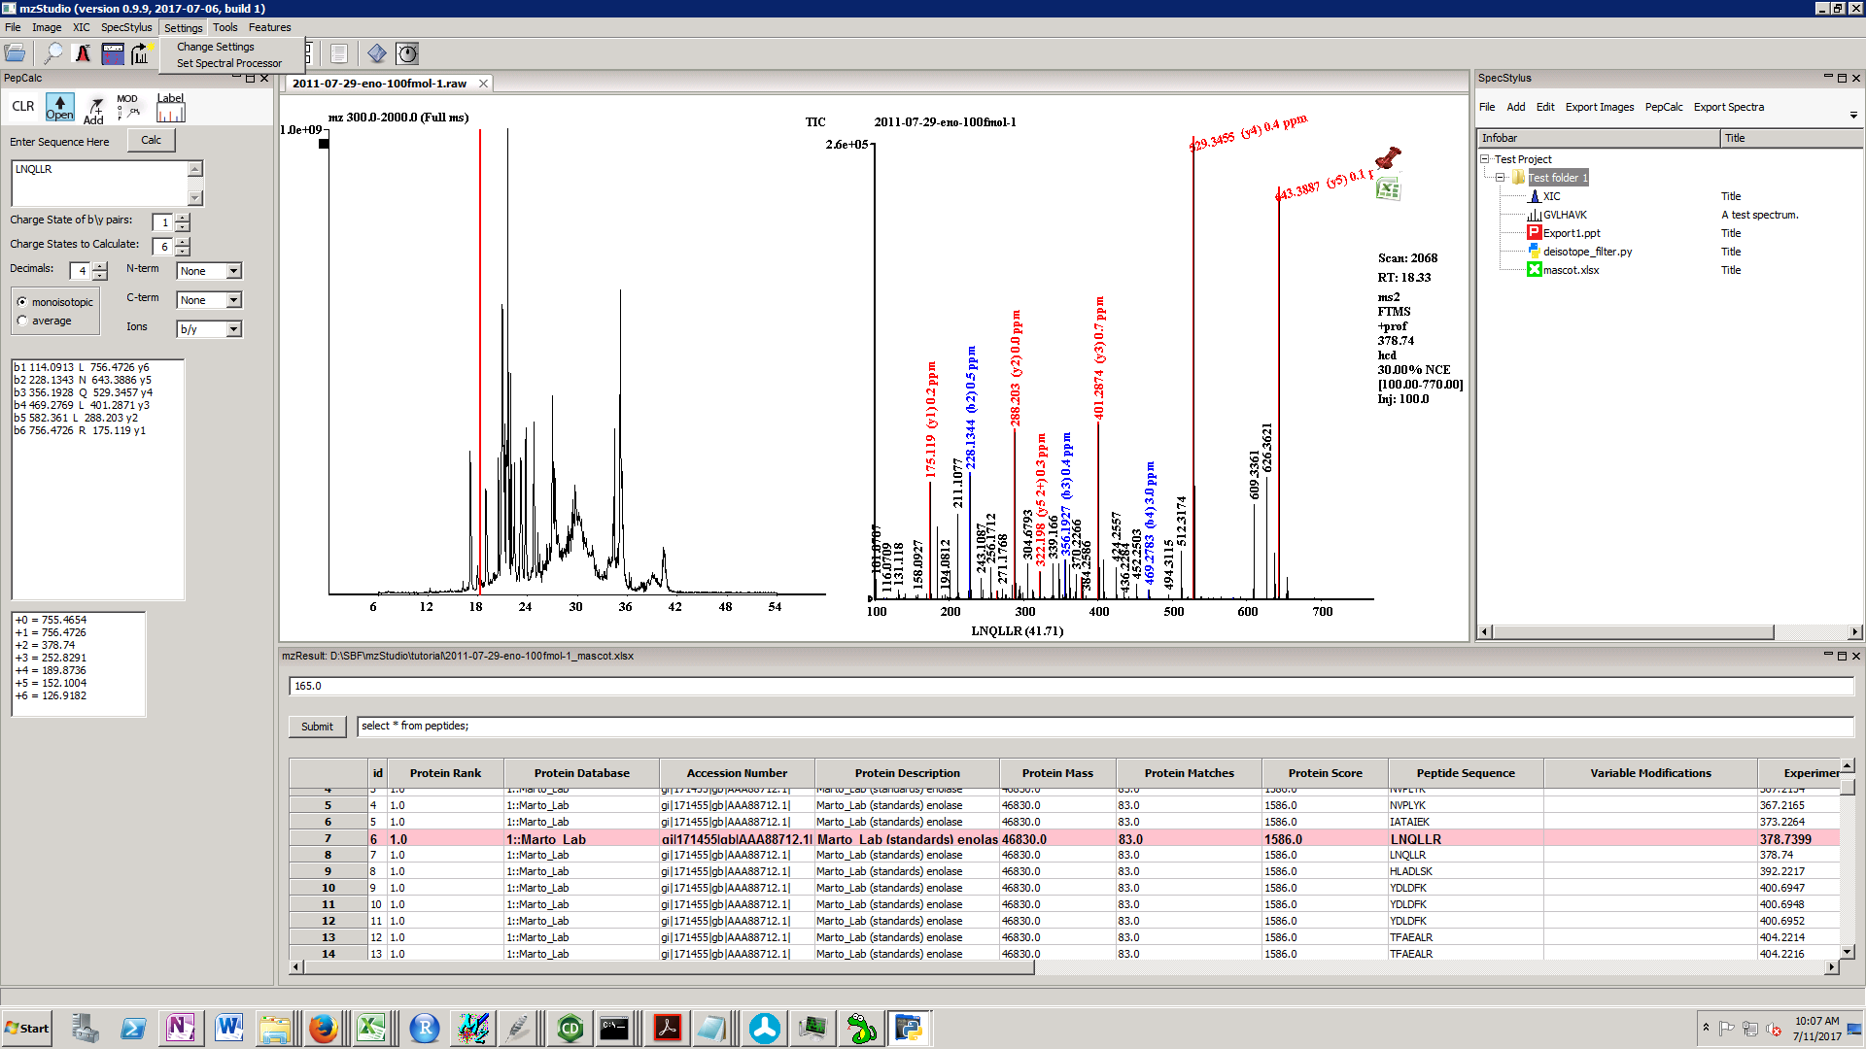

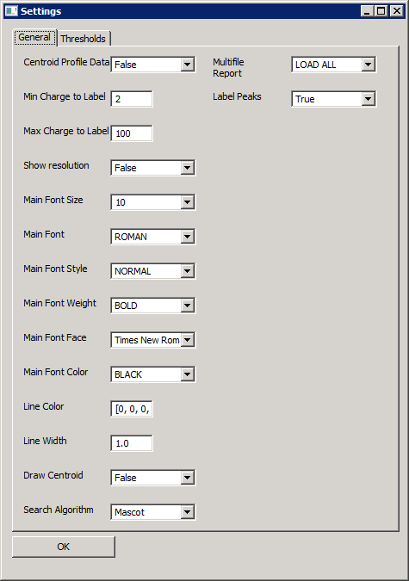

Centroid profile data (True/False)

Min Charge to label

Max Charge to label

Show resolution

Main font settings: Size, Font, Style, Weight, Face, Color

Line settings: Color, width

Draw centroid – if true, draws centroid over the profile data, if able.

Search algorithm – select Mascot, COMET, or X!Tandem.

Multifile report – when load multiplierz search result, can choose to load all relevant data files at once (LOAD ALL), or only load as needed (SEQUENTIAL).

Label Peaks – If True, draws mass label for detected peaks.

Label Threshold – Only draw mass label if signal above this threshold.

Ion label tolerance – tolerance for labeling fragment ions in mass spectra.

***Set Spectral Processor: Custom Processing Scripts***

mzStudio allows custom processing scripts to be applied to data. The script should be a .py file with a function called processor_function() that accepts a list of (mz, intensity) pairs, processes this data, and then returns a processed list of (mz, intensity) pairs for the mzStudio.

For example deisotope_filter.py consists of:

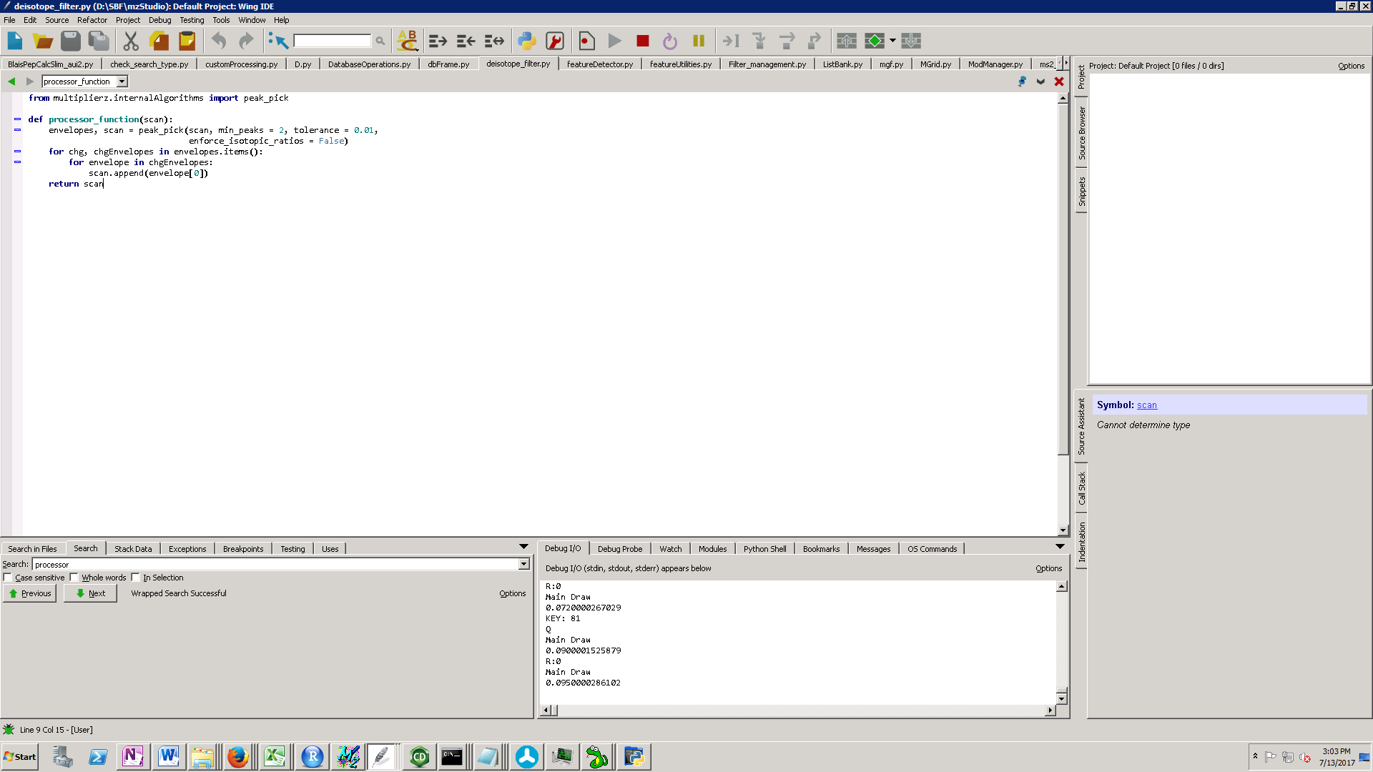

To select this spectrum as a custom processing script, select Settings/Set Spectral Processor. This opens a dialog:

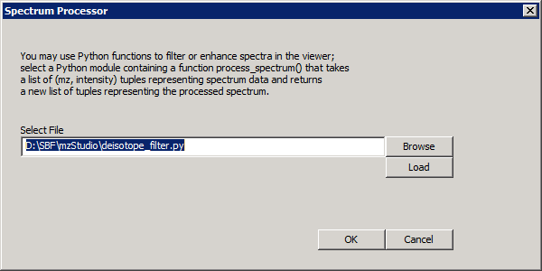

Browse to the script. Once loaded, if no errors are detected, you should see:

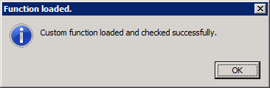

If errors are detected, you may modify the script and click Load to re-load the script.

Press Q to turn on spectrum processing; this will process the scan with the selected script and display the result.

For simplicity, we assume processing scripts will generate centroided data. Therefore, once processing is activated, the ‘view centroid’ option is selected automatically.

Exemplary spectral processing scripts can be found in the GitHub repository:

<https://github.com/BlaisProteomics/mzStudio/tree/master/example_processing_scripts>

**deiso_reduce_charge_filter.py**

Performs deisotoping and charge reduction of HCD data.

**deisotope_filter.py**

Deisotopes HCD data.

**signal_to_noise_filter.py**

Performs signal to noise filtering of data (meant for ion trap scans).

***Feature Detection***

mzStudio allows visualization of MS1-based spectral features that are detected using the multiplierz feature detection algorithm. For more information on the algorithm, please refer to:

<https://github.com/BlaisProteomics/multiplierz/wiki/multiplierz.mzTools.featureDetection>

A “feature” consists of all peaks in the isotopic envelope of a peptide through its entire elution profile.

**Step 1: Make feature file.**

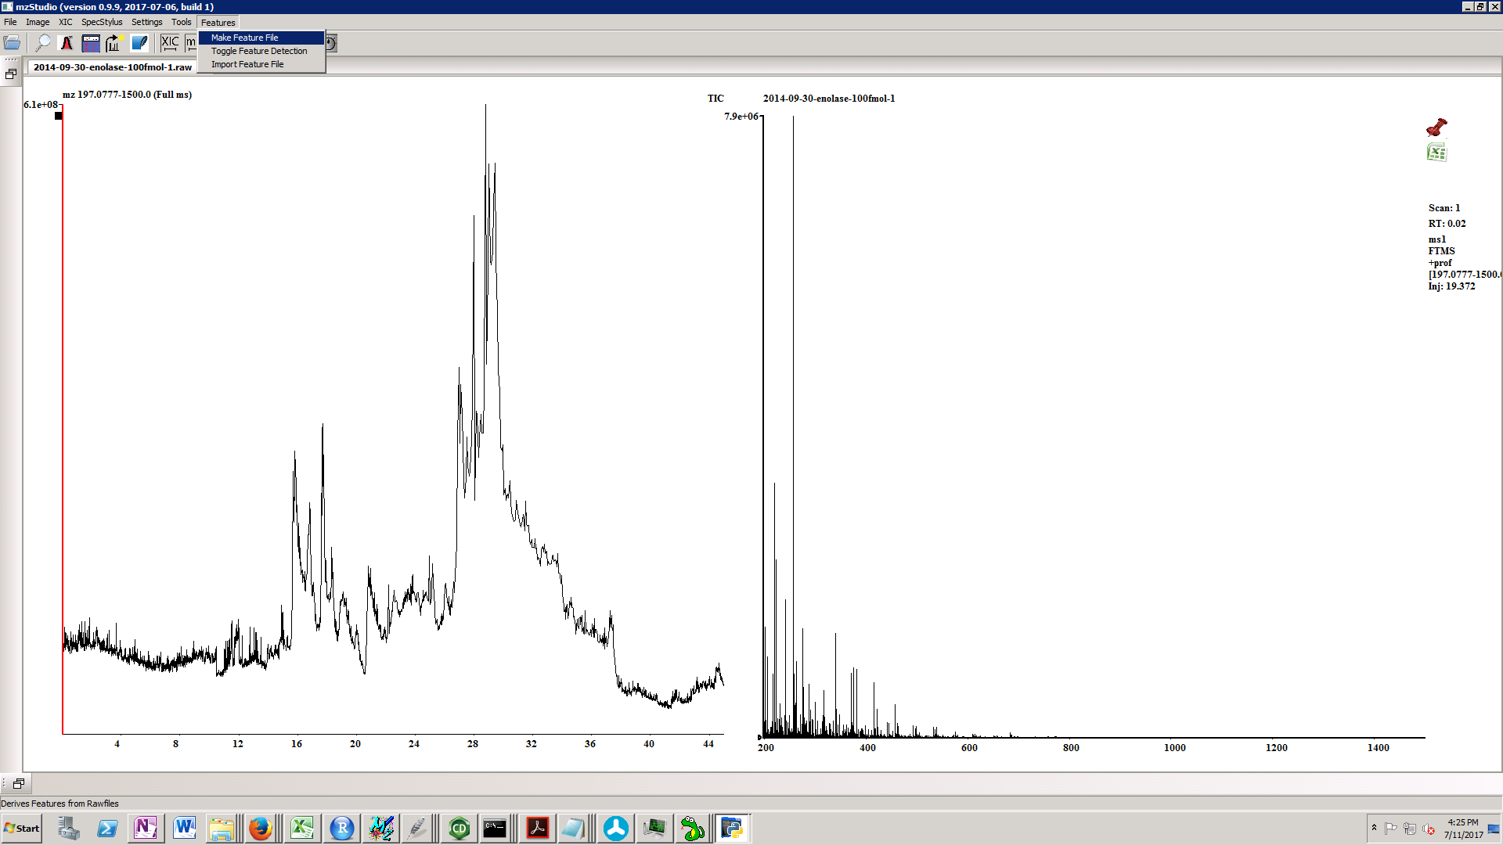

Select raw file, and multiplierz report.

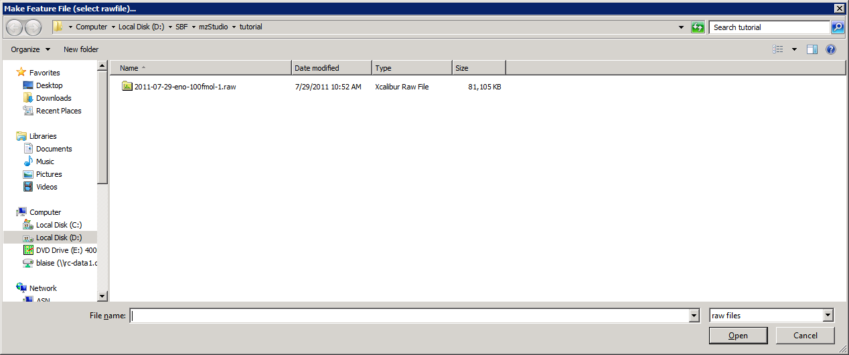

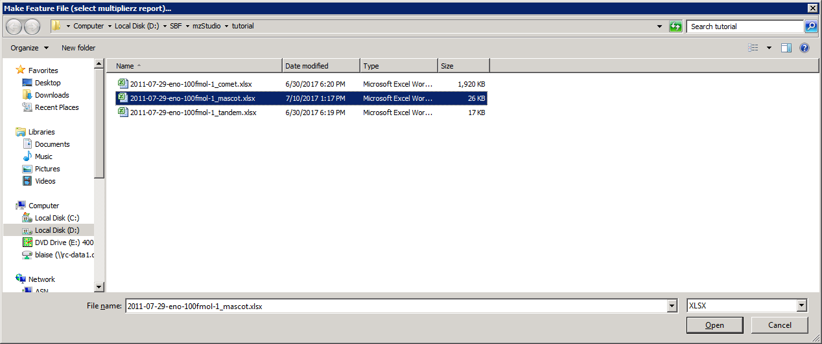

Processing with produce a file containing information about detected features (a .feature file) and a feature annotated excel file where features are mapped to PSMs.

**Step 2: Import feature files into mzStudio:**

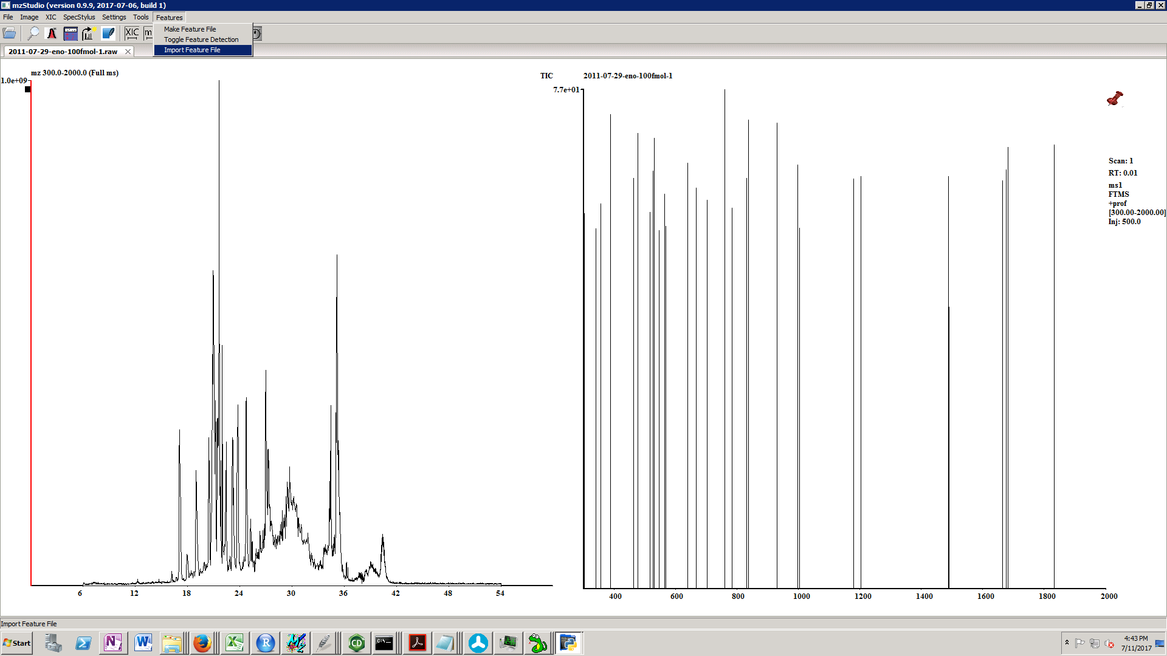

Select the feature annotated xls file:

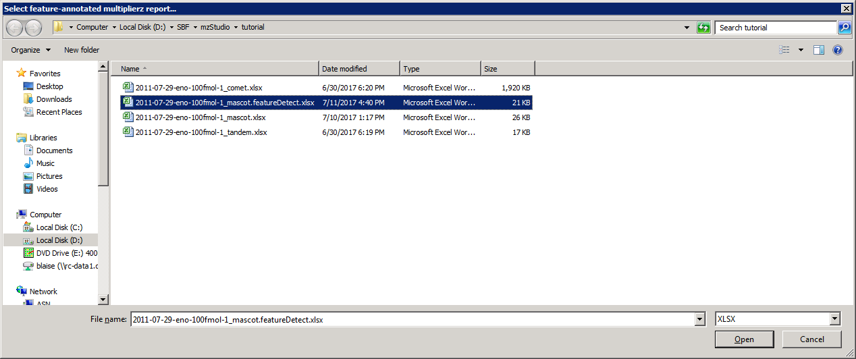

An the feature file:

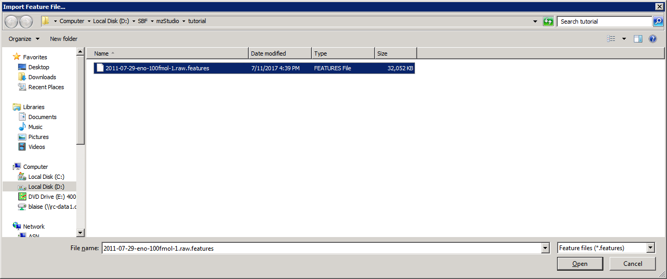

**Step 3: Toggle Feature Detection. This will turn on visualization of features.**

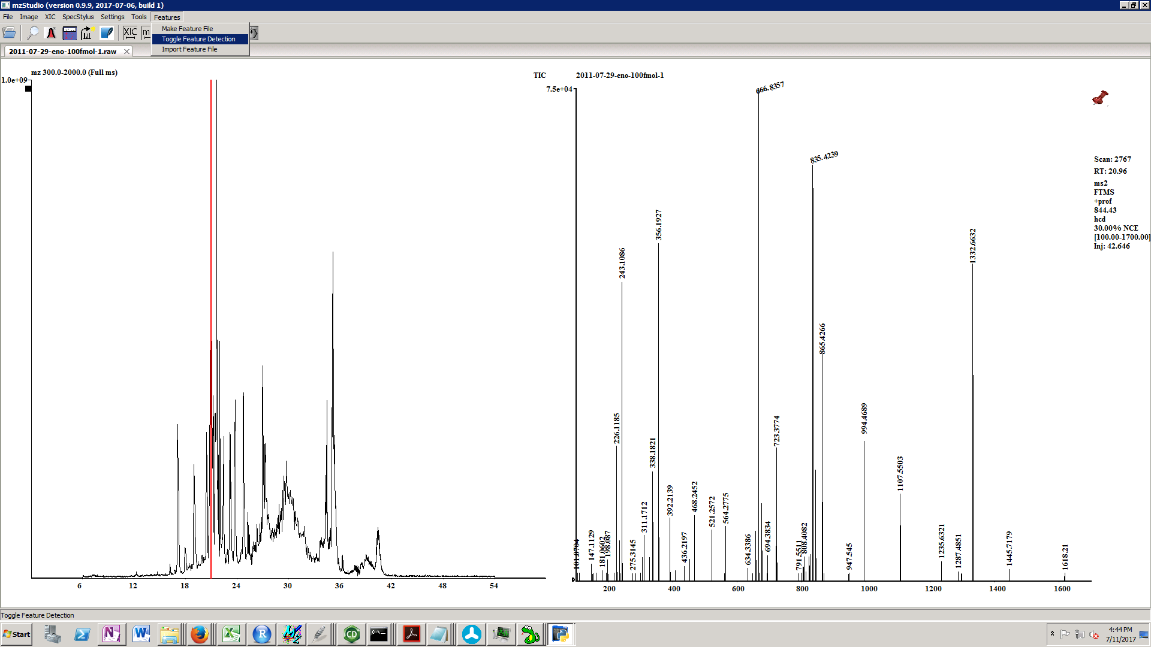

Peaks corresponding to features (including isotopes) are highlighted in red. Boxes are drawn around each feature. If the feature has an identified sequence, it is displayed (if not, it will be labeled as ‘No ID’).

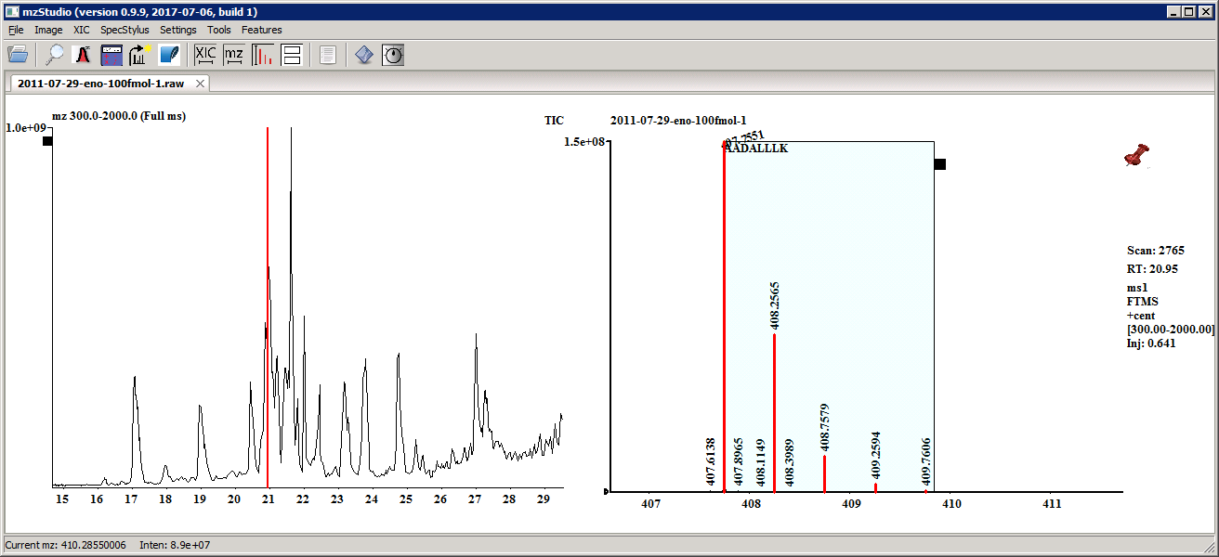

Clicking on a feature tab opens a window containing a list of MS1 scans where the feature was detected and corresponding MS/MS scans that map to the feature:

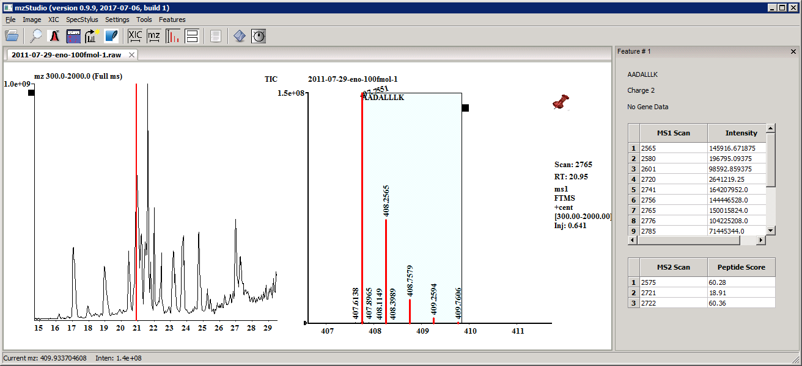

Clicking on a row label navigates to the selected scan.

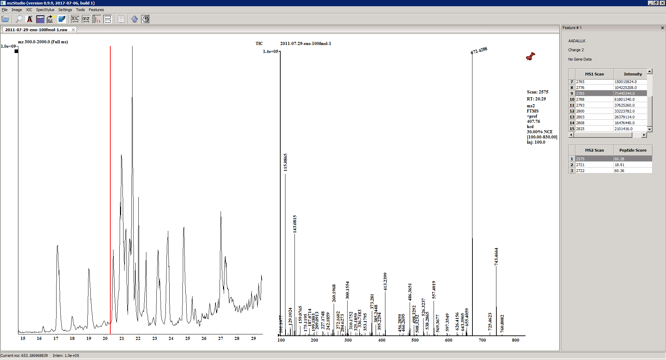

***Support for Stable Isotope LabelingWorkflows***

mzStudio has features useful for SILAC and iTRAQ/TMT experiments.

To zoom into the TMT reporter ion region, type **‘T’.** Similarly, type **‘i’** or **‘8’** to zoom in to reporter regions for 4 or 8 plex iTRAQ.

mzStudio supports viewing reporter ion signals corrected for source protein variation. To view corrected reporter ion signals, prepare a csv file with the following format:

|  |  |
| --- | --- |
| 113.11 | 1 |
| 114.11 | 0.760657 |
| 115.11 | 0.671192 |
| 116.11 | 0.825841 |
| 117.11 | 0.605796 |
| 118.11 | 0.528015 |
| 119.11 | 0.8329 |
| 121.12 | 0.955312 |

This file contains each reporter ion m/z followed by its experimentally determined correction factor.

Press ‘4’ to browse to and load this csv file. Once selected, source protein variation corrected signals will be drawn to the left of each peak.

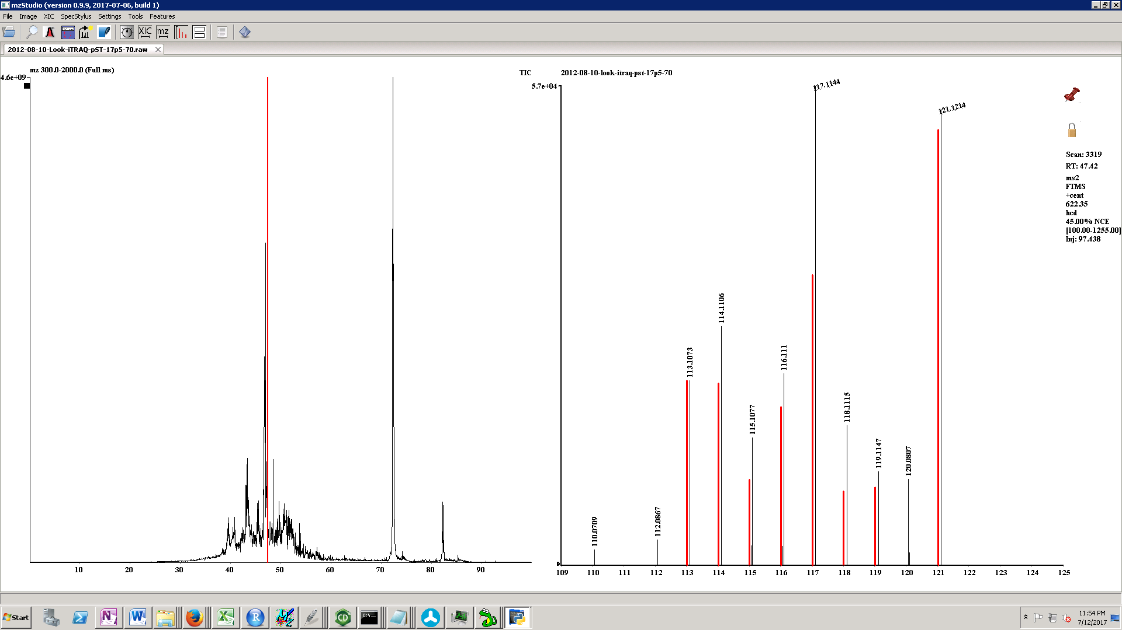

In a multiplierz report from a SILAC experiment, the SILAC labels are detected from the Mascot_Header worksheet (QUANTITATION METHOD row). When a SILAC experiment is detected, clicking on a PSM in the mzReport grid will navigate to the MS2 scan. If you press +/- or <> to navigate to the MS1 scan, mzStudio will highlight light, medium, and heavy analogues corresponding to the PSM.

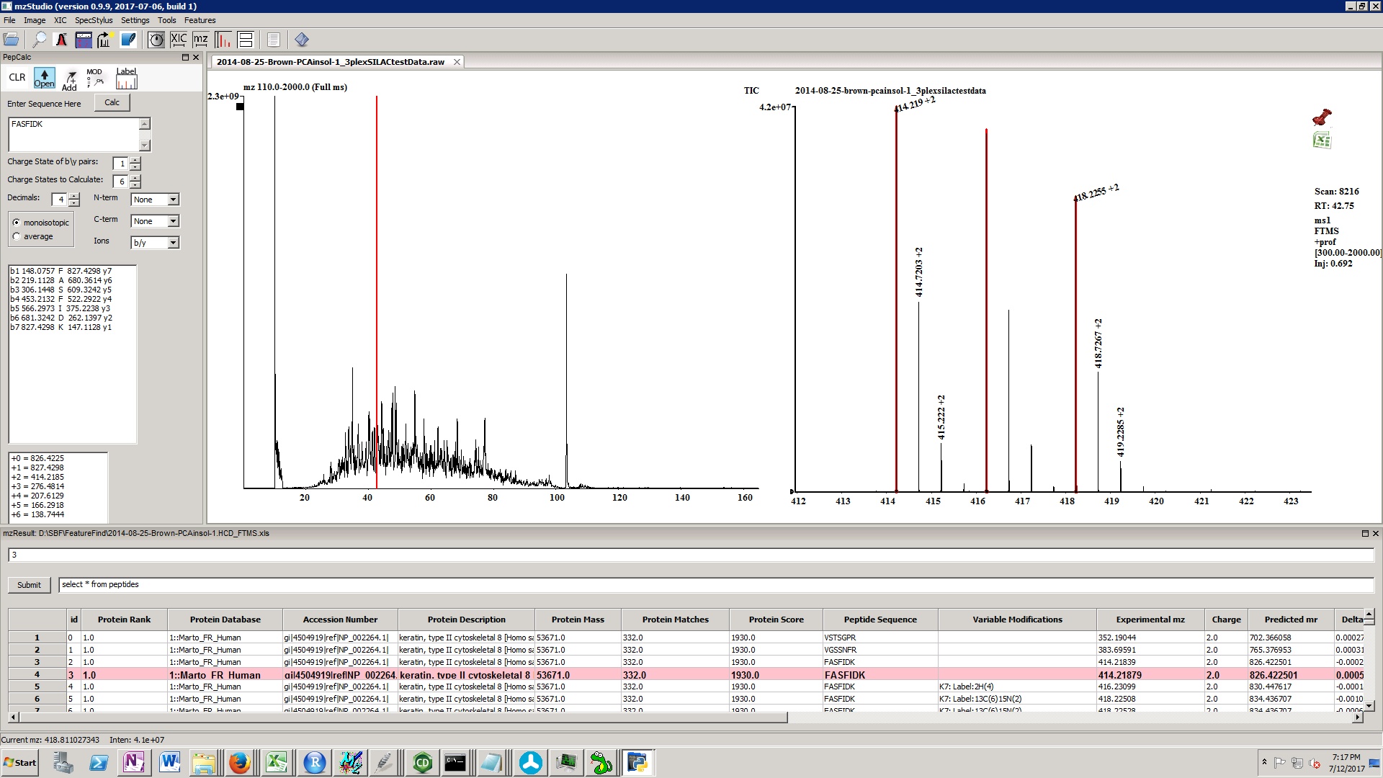

***Peak Areas***

Peak integration can be performed by right click and drag within the XIC window. There are two possible methods for integration, sum and guassian fit. The method used is selected in the settings menu. SUM is the default method.

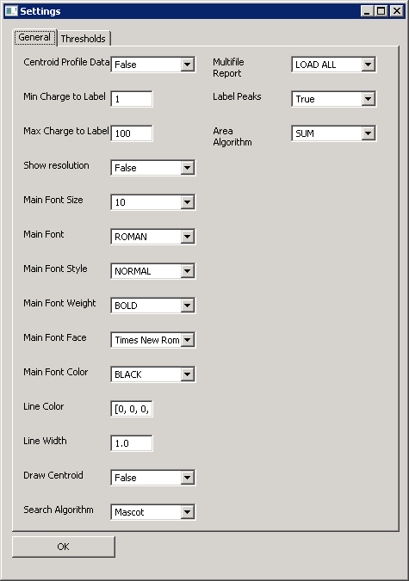

This method simply calculates the sum of (width*height) of rectangles across the selected range, where width is time[n+1] – time[n] and height is (intensity[n+1] + intensity[n])/2 (from 1 to n-1).

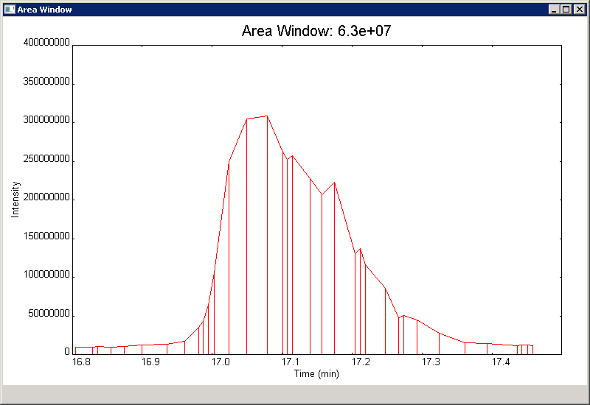

To use the Guassian fit method, you first must install Scipy, which requires numpy+mkl. A handy place to obtain modules like these is Gohlke’s site: <http://www.lfd.uci.edu/%7Egohlke/pythonlibs/>

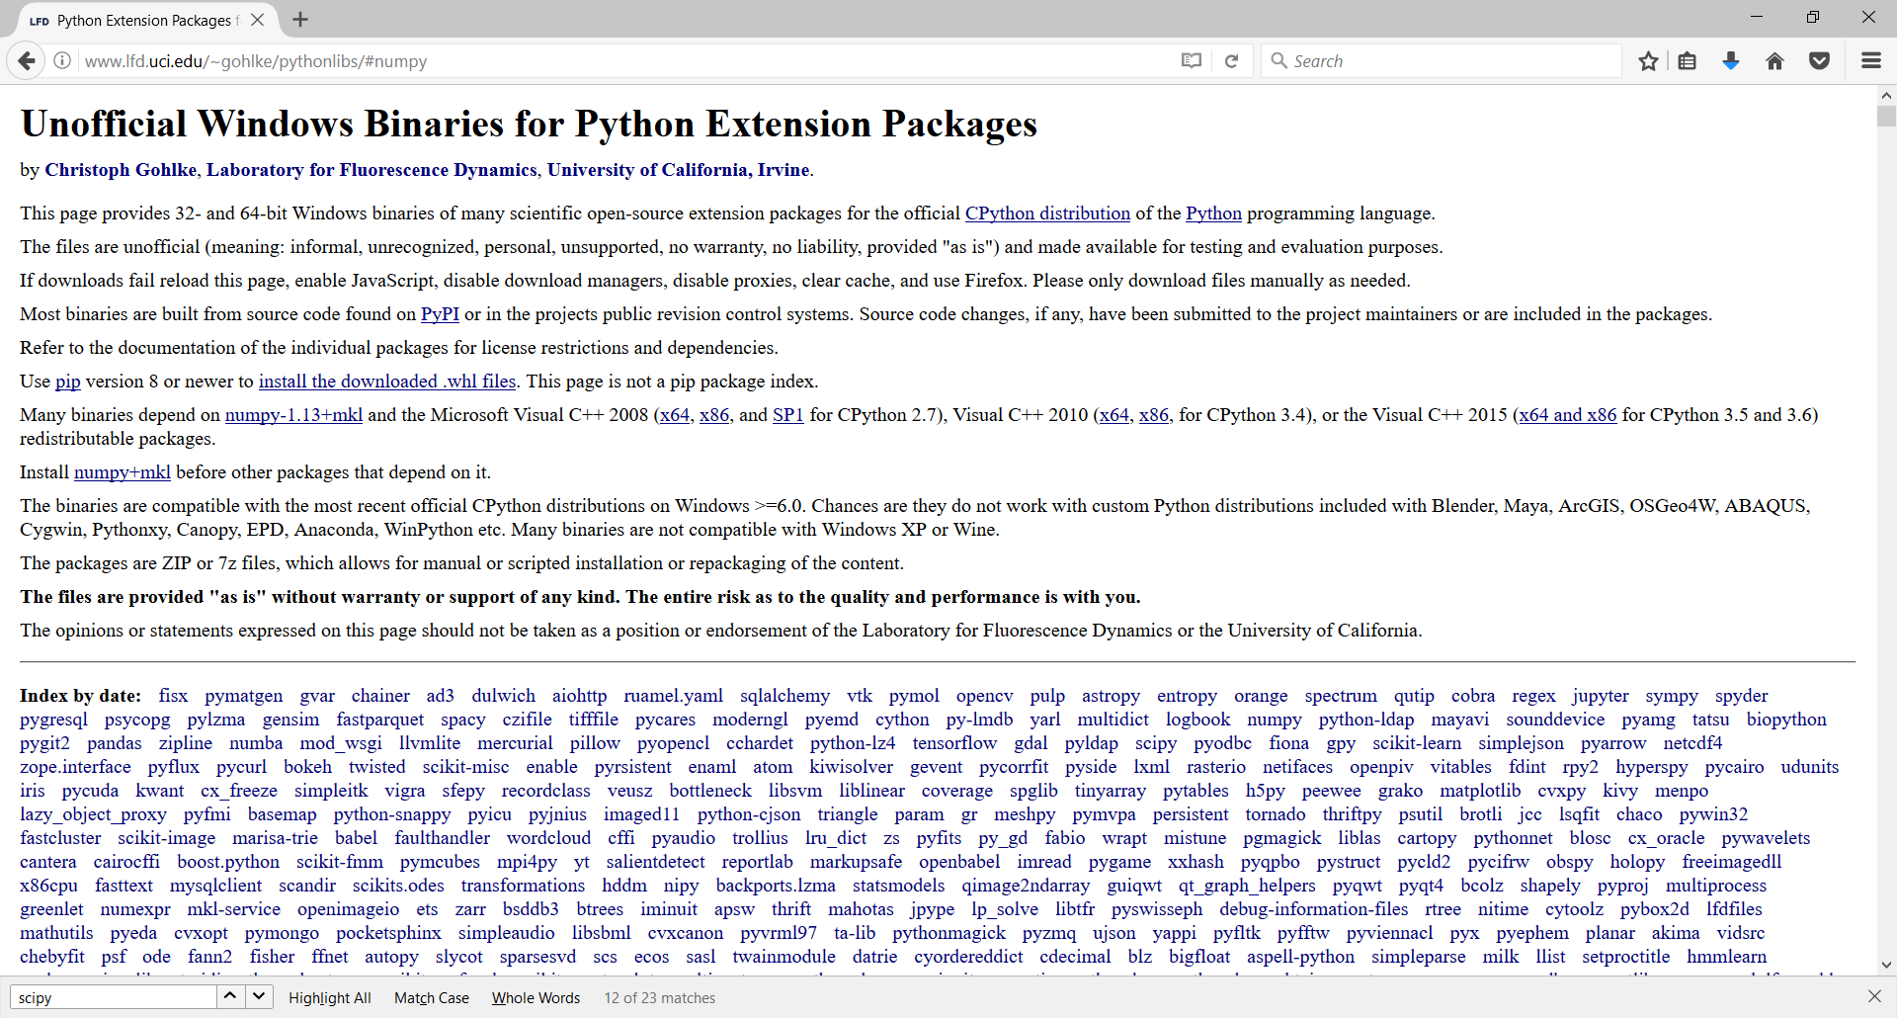

Download numpy (+ mkl):

[numpy‑1.13.1+mkl‑cp27‑cp27m‑win_amd64.whl](javascript:;)

Install the whl file with pip:

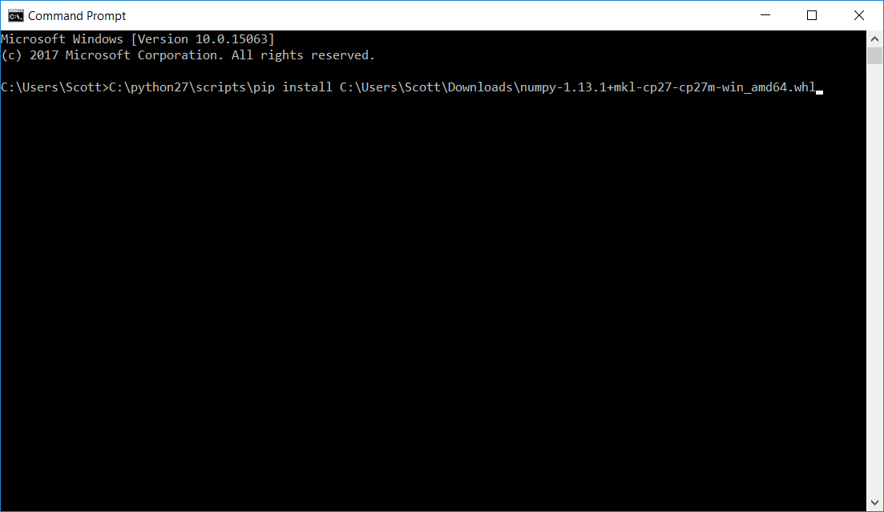

Download scipy:

[scipy‑0.19.1‑cp27‑cp27m‑win_amd64.whl](javascript:;)

Install the whl file with pip;

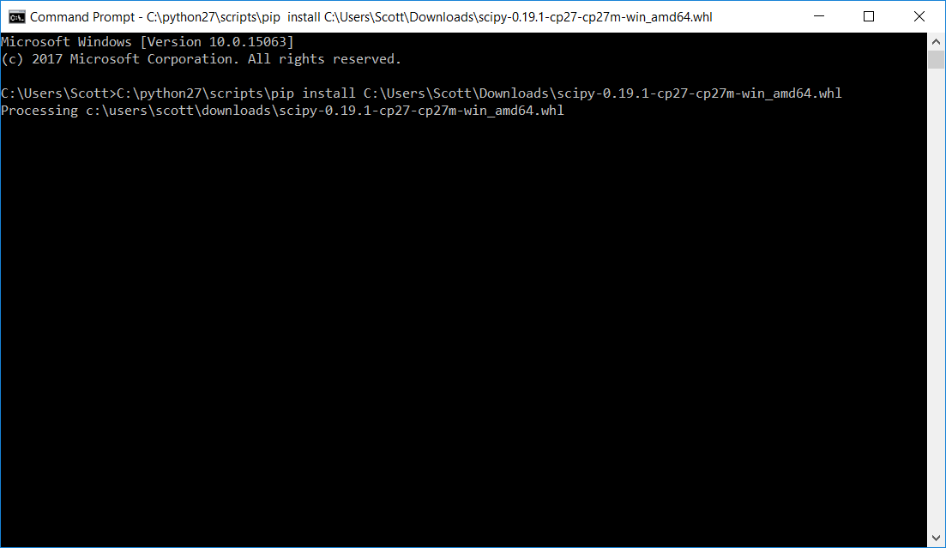

Select GUASSIAN under area algorithm:

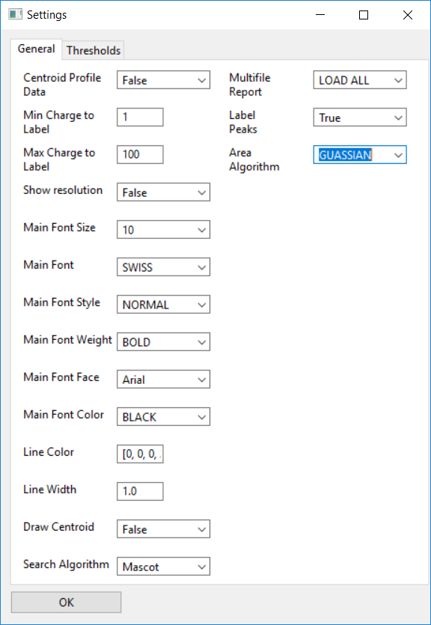

Now right click and drag across a peak performs a Guassian fit of the data.

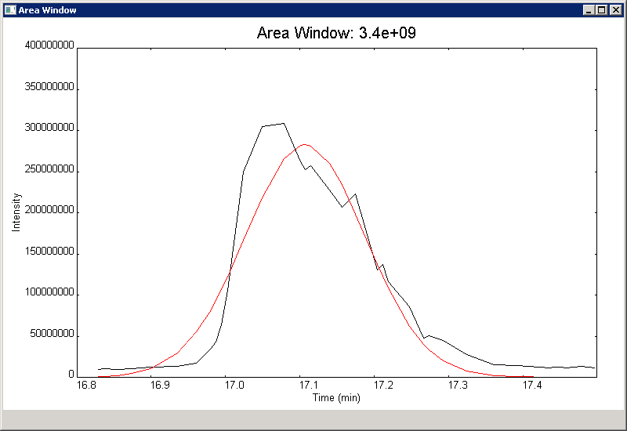

A handy way to keep track of areas is with the area bank tool from the tools menu:



When this tool is open, all integration values are appended to the bank (tab delimiter).

Use the copy button to copy all the values for pasting into excel.

***Managing Windows***

mzStudio uses the AUI/AGW (advanced user interface/advanced generic widgets) docking library. AUI panes may be floated and docked to optimize visualization. If the spectrum/XIC window is too small, you will see a message “Can’t display! Resize!”. When you are ready to view the window, just re-adjust the window splitters until you can see the data displayed.

***Compatibility***

mzStudio interacts with COMET, X!Tandem, and files from Proteome Discover. Changes or updates to these software packages may impact usability.

We have tested mzStudio with:

COMET version 2016013

X!Tandem version tandem-win-17-02-01-4.

Mascot 2.2-2.5.

Proteome Discoverer version 2.1.0.81

mzStudio has been successfully installed on 64 bit Windows server 2008, Windows 7, and Windows 10 operating systems.

***Exporting PDFs***

To export PDFs, two additional python libraries need to be installed: svglib and reportlab.

Both are easily installed with pip:

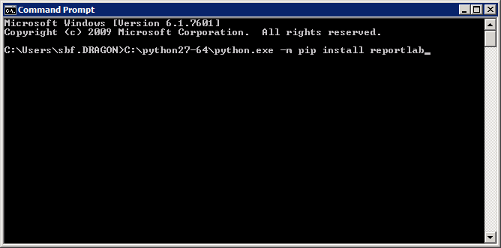 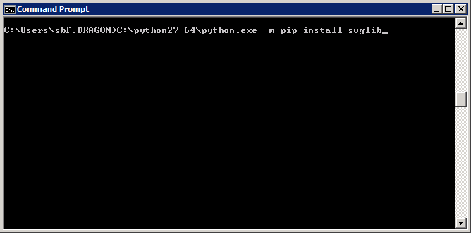

***Installing COMET, X!Tandem***

**COMET**

Go to sourceforge, and download comet_2016013.zip. Extract files to an appropriate directory.

<https://sourceforge.net/projects/comet-ms/files/>

comet_2016013.zip

**X!Tandem**

Go to the X!Tandem ftp site and download tandem-win-17-02-01-4.zip. Extract files to an appropriate directory.

<ftp://ftp.thegpm.org/projects/tandem/source/>

tandem-win-17-02-01-4.zip

***Configuring Comet, X!Tandem and Mascot for use with mzStudio***

**OVERVIEW**

To configure search engines with mzStudio, navigate to the settings file in your *multiplierz* directory, which will be found at

**C:\Users\<your username>\.multiplierz\settings.txt**

To enable Comet and X!Tandem, indicate the path of the respective executable(s) in the ‘comet directory’ or ‘xtandem directory’ fields. To enable Mascot, set the ‘mascot server’ field to the URL of your Mascot server (e.g., http://my_server.com/mascot) , set the ‘mascot version’ field to the appropriate version number (e.g., 2.5) and, if you have Mascot security enabled, the ‘mascot security’ field to 1.

**DETAILED CONFIGURATION GUIDE**

**MASCOT**

As mentioned above, to set up mzStudio to perform Mascot searches, go to your “.multiplierz” folder in your User directory and open Settings.txt with notepad or another text editor:

C:\Users\sbf.DRAGON\.multiplierz

(Note, the directory will be specific to your user account).

Open Settings.txt

Enter your Mascot Server IP address, version, and other settings (see Mascot user’s guide for further information about each setting):

# Mascot

mascot server=http://cys.dfci.harvard.edu/mascot

mascot version=2.4

mascot ms2=1

mascot security=1

mascot var_mods=1

mascot max hits=100000

mascot ion cutoff=5

mascot bold red=False

mascot show input query=True

mascot rank one only=True

mascot pep quant=False

mascot retain DAT=False

mascot genbank=False

mascot sub-set hits=True

mascot protein summary=False

mascot p2g=False

mascot mzid=False

mascot same-set hits=True

**COMET**

Open the settings.txt file as described above, and set the path to your COMET executable:

# Comet

comet directory=C:\Users\sbf.DRAGON\Downloads\comet_2016013\comet.2016013.win64.exe

**X!Tandem**

Open the settings.txt file as described above, and set the path to your X!Tandem executable:

# XTandem

xtandem directory=C:\Users\sbf.DRAGON\Downloads\tandem-win64-17-02-01-4\tandem.exe

***Known issues***

Currently known bugs/issues and enhancement requests can be found at:

<https://github.com/BlaisProteomics/mzStudio/issues>

Find a bug? Have a feature request? Open a ticket! Or send an email to:

[Scott_Ficarro@dfci.harvard.edu](mailto:Scott_Ficarro@dfci.harvard.edu) or

[WilliamM_Alexander@dfci.harvard.edu](mailto:WilliamM_Alexander@dfci.harvard.edu)